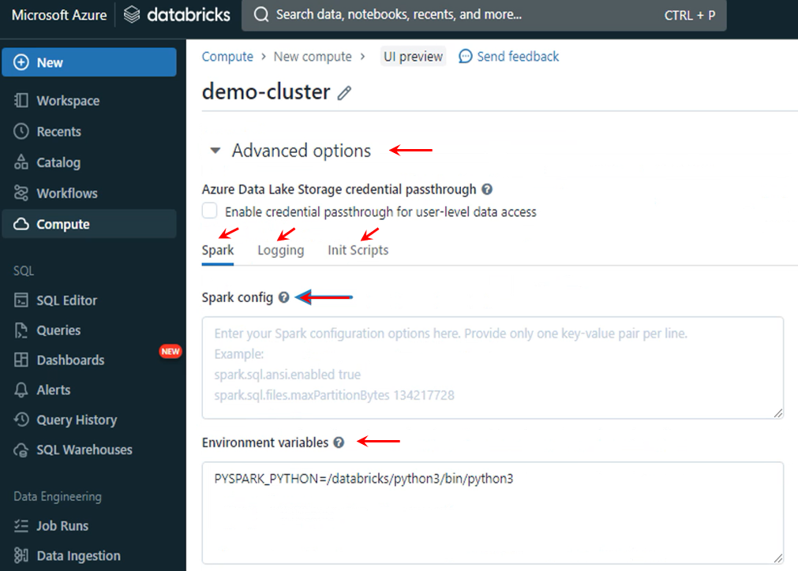

You can specify default spark configurations and environment variables. Databricks will set these configuration and environment variables appropriately before launching the cluster. Once those configurations are set, they become default configurations for your spark cluster. You can change any of those configurations later for your application, but you can use this place to set some defaults. Databricks automatically sets good default values, so it is acceptable to skip this place and accept Databricks defaults. The cluster logs are not collected by default, but if you want, you can set the log location and Databricks will start collecting cluster logs.

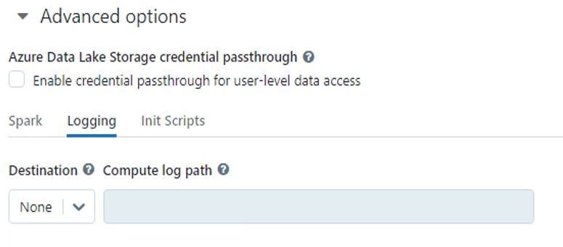

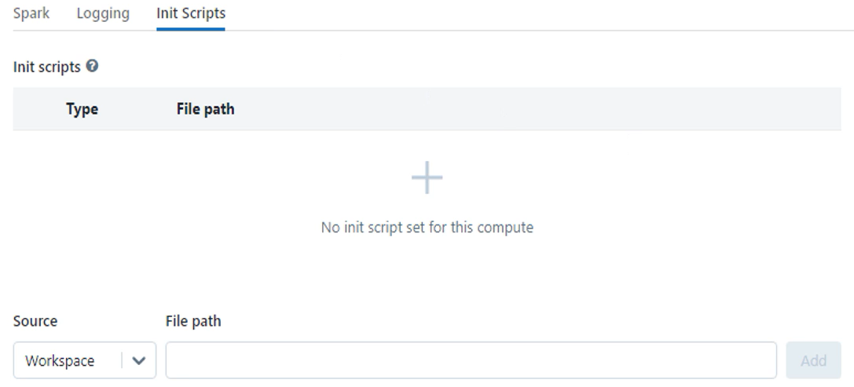

The last option is to specify the init script. This location is to supply a cluster specific init script. These are nothing but shell scripts to install or configure something on the VM, even before the spark cluster starts. That's all in the advanced options. You can also see the estimated cost of your cluster in this summary section. It shows you the estimated cost in DBUs. But what is this DBUs per hour? The DBU is known as the Databricks Unit. It is an indicator of the Databricks charges.

|  |  |
| --- | --- |
|  | They are showing 1 to 3 DBU per hour for the selected configuration. That means Databricks will charge somewhere between 1 to 3 DBU for the one hour runtime of this cluster, you will get a consolidated bill from Azure, including DBU and hardware costs for running these VMs and other resources. But DBU is the cost to Databricks only.  The total cost includes the DBU cost plus the Azure resource cost. But what is DBU and how does it translate to currency? Well, you can check the documentation for this, but I roughly take it as 1 USD for the DBU. It is often less than 1 USD, but you can take it as 1 USD per DB. |

|  |  |
| --- | --- |
|  | You cannot create a multi-node cluster if you are on a Azure Free account, and Azure Free account subscription allows you to use four CPU cores at a time. That is the maximum limit set for the free account. This cluster configuration requires two worker nodes and one driver node. Each of these nodes should have four CPU cores, so the total comes to 12 CPU cores, right? But the free account can have only up to four CPU cores. So you cannot create this multi-node cluster using a free account. Azure will lift this restriction when you upgrade your subscription to a pay as you go plan, but nothing to worry about. Let's see what options we have in a single node. Let me change it to a single node. |

You can still choose your access mode. All these are supported. We do not have an auto scaling feature for single node clusters. Why? Because it is a single node cluster. Auto scaling is not applicable. A single node Databricks cluster is more than enough for learning and development activity, and you can easily create this cluster using your Azure free account. So I'll create this cluster and use it for learning, I will create a multi-node cluster for some of the lessons. When having a multi node cluster, it is really necessary to understand some concepts. So we will use a single node cluster when it is not essential to have a multi node cluster. But when explaining things that need a multi node cluster it is essential. Lets remove the photon engine because we do not need it. Do not forget to check two things. Check the node type and your DBU cost in the summary. Make sure you create a small learning cluster and keep your costs low. Set auto termination time to 30 minutes or lower. Let me create the cluster.

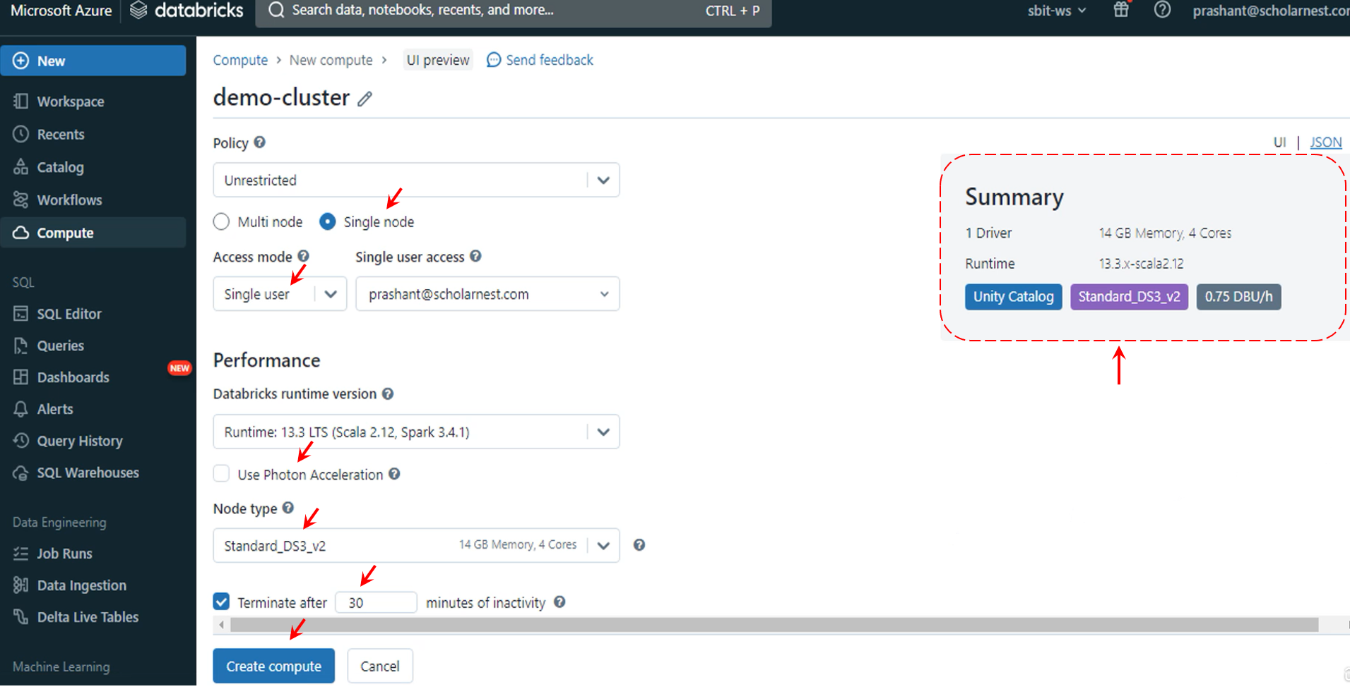

Databricks is now creating and launching a cluster for us. It may take up to 5 to 7 minutes to start the cluster.

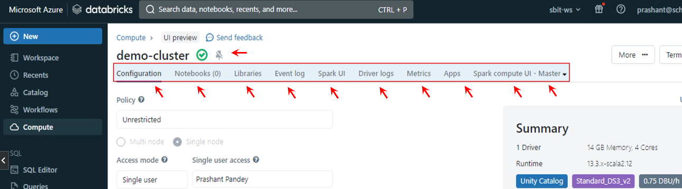

My cluster is now ready. Once your cluster is started, you will see some tabs at the top of the page. The first one is the notebooks tab. This tab shows the active notebooks that are attached to this cluster. We have nothing yet, so we do not see anything here. But when we start creating some notebooks, you will see them here.

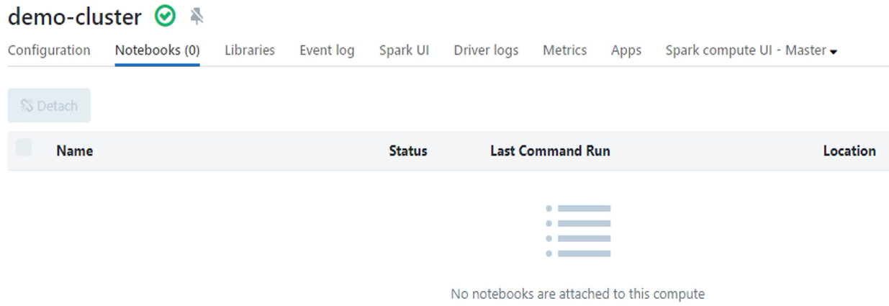

The next one is for libraries. This tab allows you to install additional libraries on your cluster.

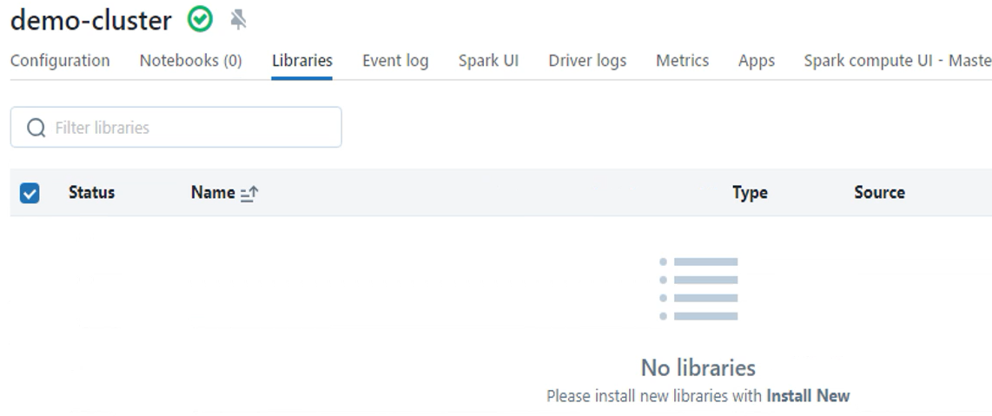

The next one is the event log. These are the log entries created during the start and stop times of the cluster.

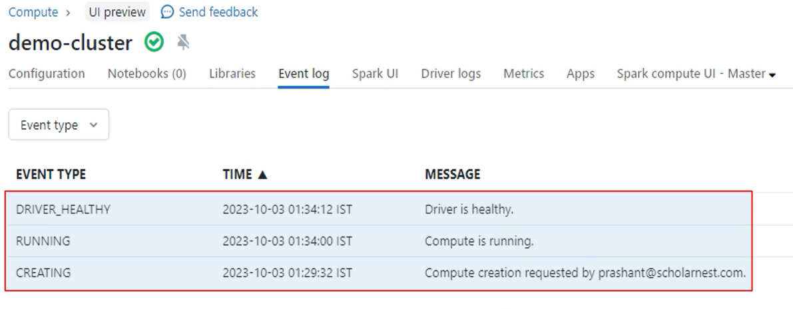

The next tab presents you with the spark UI. If you know his part, you already know it, right? You can change the tabs within the spark UI and look at the running jobs. But we do not have anything, so nothing is showing here.

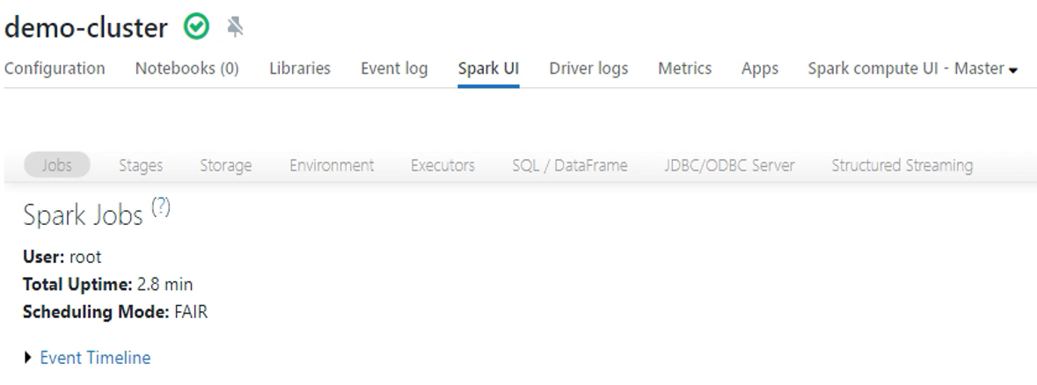

The next tab is a place to see your driver logs. You will see three sections here.

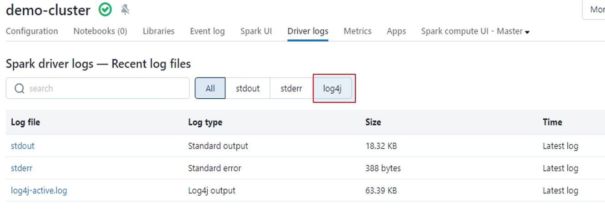

The first one is a standard out. Then we have a standard error. And finally you have log forge output. The next one is for matrices.

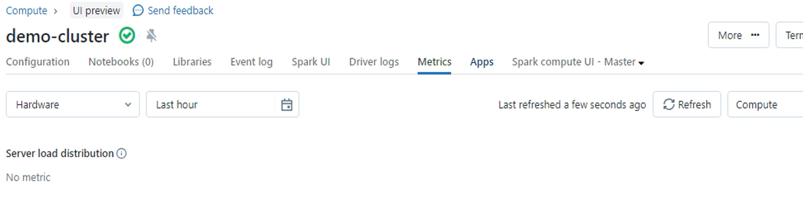

Azure Databricks comes with a ganglia metrics monitoring system pre-configured so you can go to Ganglia Metrics UI and look for cluster matrices. Databricks is also working on integrating apps such as web based terminals and RStudio.

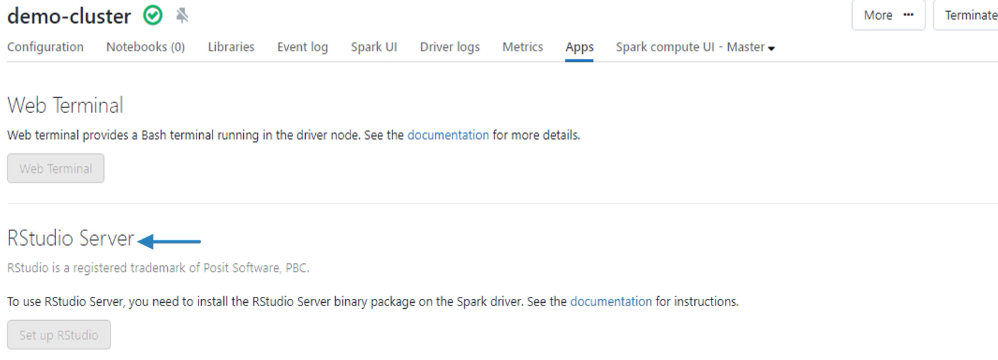

The last one is again a shortcut to the spark UI. It duplicates the same spark UI tab you have shown earlier.

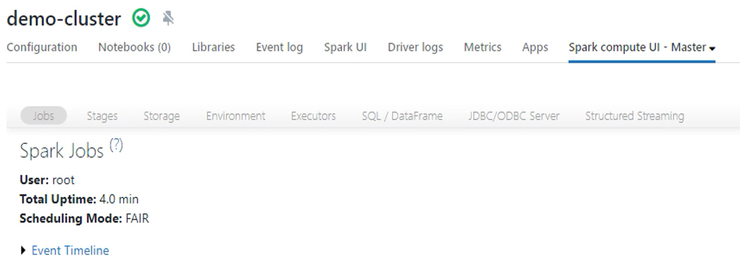

Now let's come back to the configuration tab. You can see the edit button here at the top of the page.

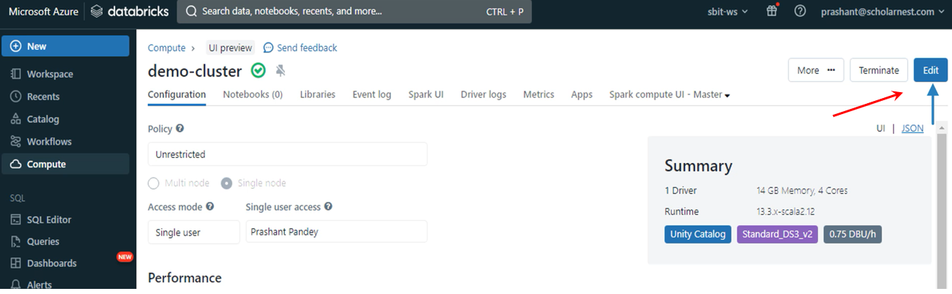

So you can come back here and change the cluster configuration. You can even change the Databricks Runtime version. Change the auto termination duration. You can even change the node type.

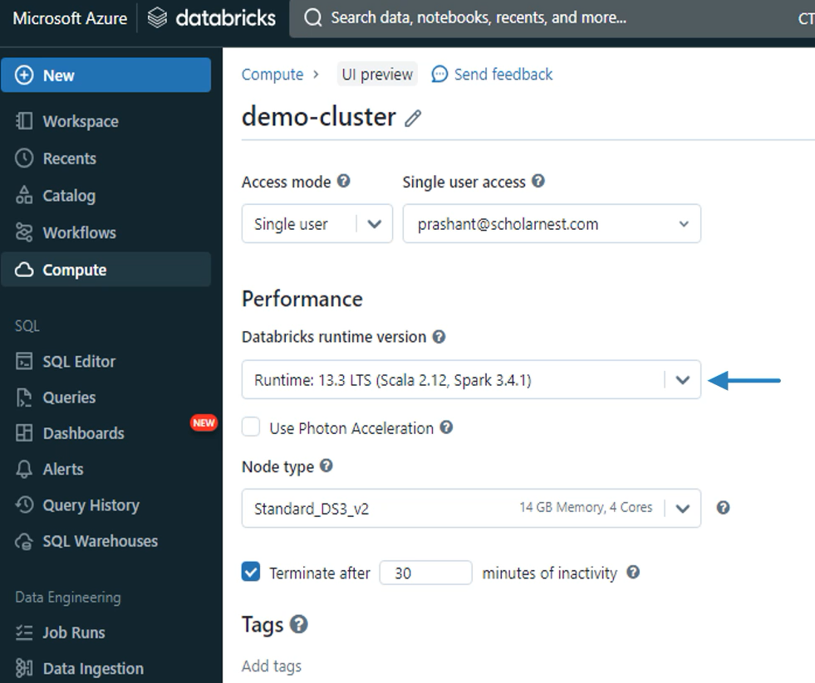

Some changes will apply without restarting the cluster, but others may restart the cluster.

Let's cancel and come back. We also have a terminate button so you can terminate the cluster. So my cluster is no longer running. If you want, you can delete it permanently by going inside the more button. But let's not delete it for now. Come back to the compute menu to see the list of clusters. All your clusters are listed here.

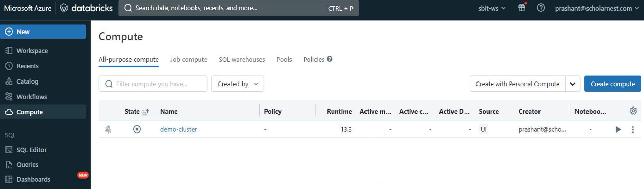

They might be terminated or running, but you can see them here. You can start your cluster if it is in the terminated state, but I am not starting it. Let me go back to my Azure portal. Let's see all the resources.

So you can see a bunch of resources now and you can see a virtual machine here. It is not running because I terminated my cluster, but I can still see the resource here in the terminated state. You can also see two disk resources, two network interfaces, and one public IP address. All these are created and used by Databricks for a single node cluster. They remain here in the resources list even if the cluster is terminated.

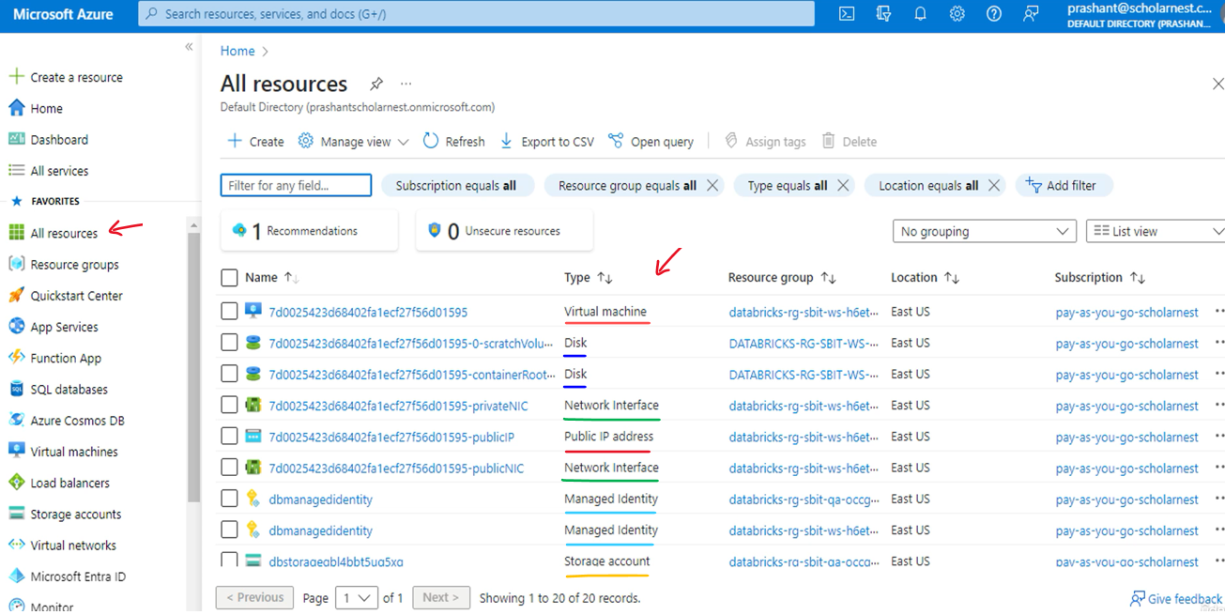

Azure will still charge you for resources such as disk and public IP. That's a small amount, but you will get some charges. Now let me return to the Databricks workspace and permanently delete the cluster.

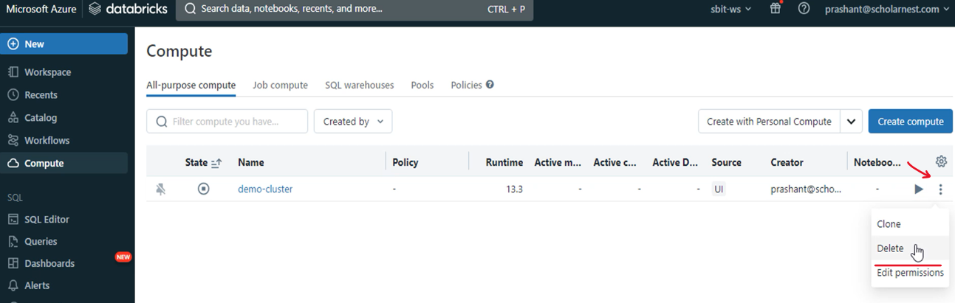

Go back to the Azure portal after a few minutes and recheck the resource list. There will be all gone. Azure might take up to ten minutes to clean up the resources and refresh the resource list, but when you permanently delete the cluster, Azure will clean up the resources and they will not charge you anything. The point is straight. If you are learning, delete your cluster after the practice it will save you some cost.

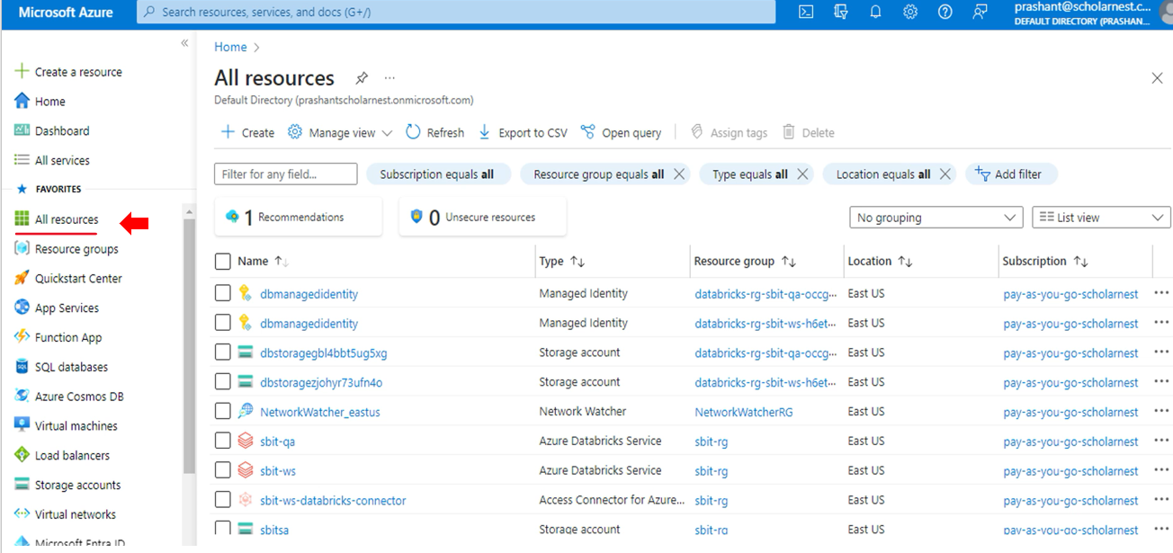

Databricks Notebook. So let's start. Here is my Azure Databricks workspace. You can create notebooks using the shortcut on your workspace home page and write code. However, we recommend you to go to the workspace menu. Let me go there. Now expand the workspace folder. You can see shared and user folders already created there. These are default folders. Right click the workspace directory and create a new folder. Give a name to your folder.

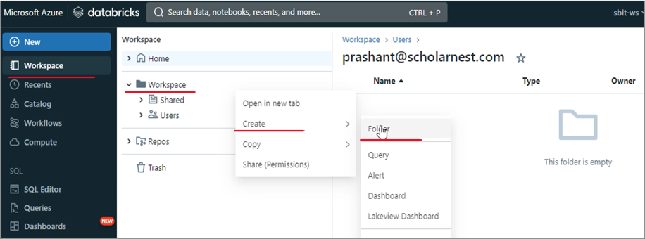

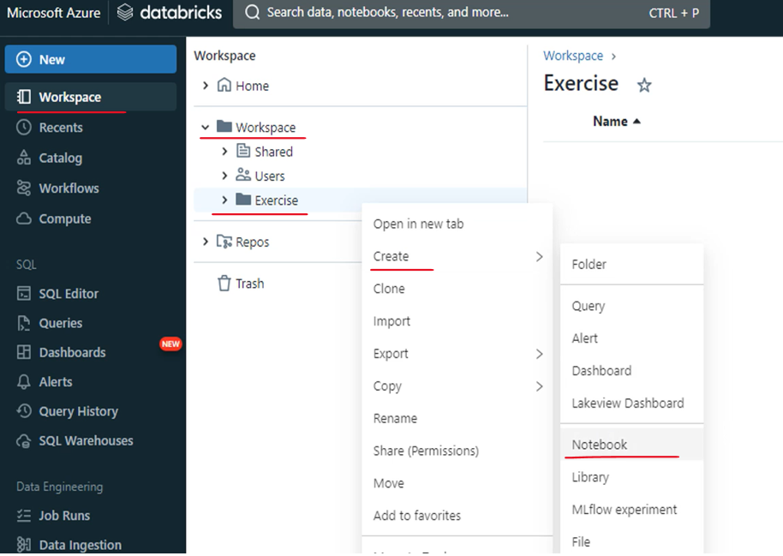

Right click the exercises and create a new notebook. Databricks will create a new notebook with a default name. You should change the name and give your notebook a meaningful name. Every Databricks notebook has a default language. This one is a Python notebook. You can see the default language of the notebook next to the notebook name. If you want, you can change the notebooks default language. We have four options Python, SQL, Scala and R. Let's keep it Python. Databricks Notebook is your code file. You can write code in your notebook and run it. However, a notebook runs on a cluster, so you must have at least one Databricks Spark cluster already running.

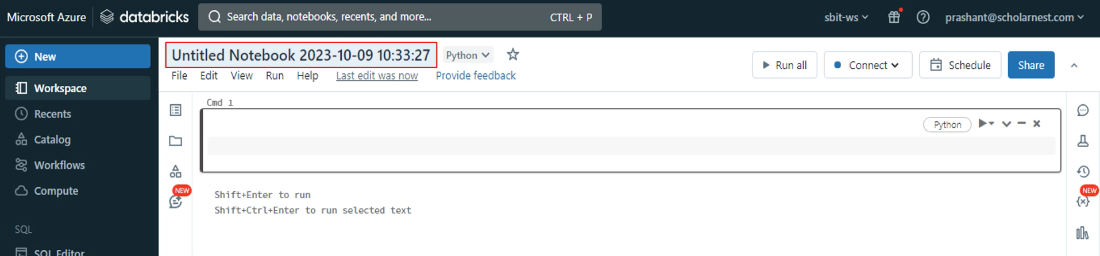

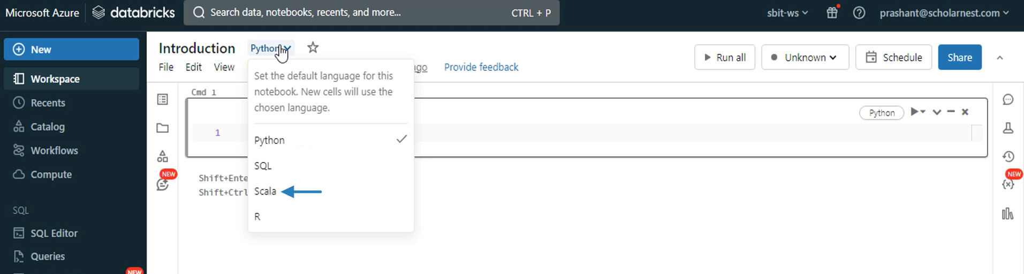

Databricks Notebook is your code file. You can write code in your notebook and run it. However, a notebook runs on a cluster, so you must have at least one Databricks Spark cluster already running. Then you can attach the notebook to the running cluster. We already learned to create clusters in the earlier lecture, but I deleted that cluster. So let me create a new cluster for running this notebook. Click this connect button at the top. If you have a running cluster, you can see that in the drop down list. But I do not have a cluster, so let me create a new one from here. Click create a new resource to create a new cluster.

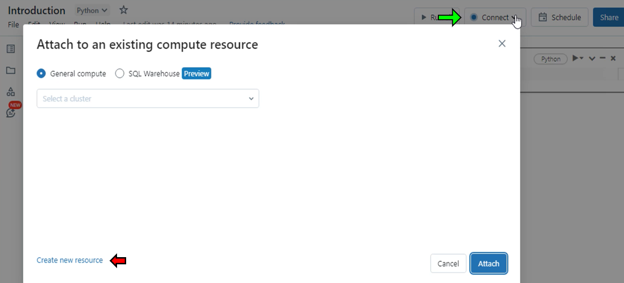

Choose the personal compute policy. Give a name to your cluster. Select 14 GB and four core VM. Choose a standard and latest runtime version. Review your summary to ensure you chose a low cost debut. Now hit the create button.

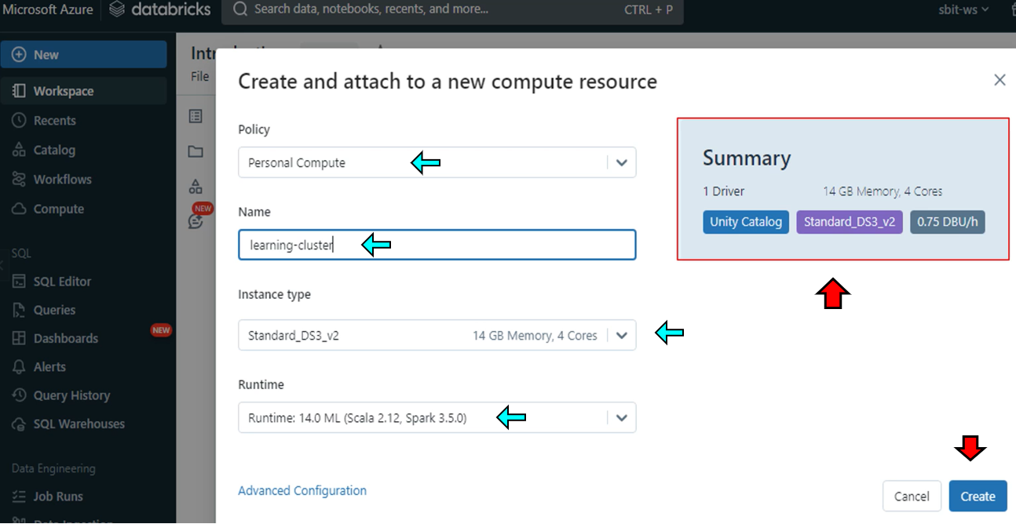

Databricks will launch a new cluster and attach this notebook to the cluster, and once attached, you can execute your notebook code while the cluster is starting.

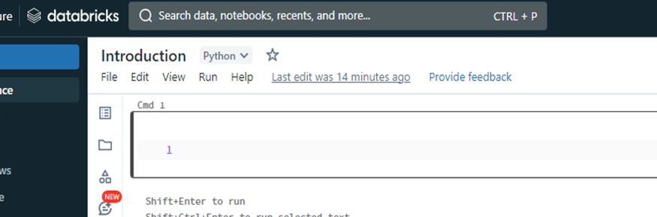

Here is my notebook. It shows me a line number. Click on line one and you can start writing code here. We write code in notebook in small sections and each section is known as notebook cell. So I am currently in the first cell of the notebook. This box shown here is a notebook cell. The default language of my notebook is Python, so you can write Python code in this cell. Let me define a hello world string. Great. So you can press enter and write more Python code lines in the same cell. But let's keep a single line in this cell and run it. How do I run this cell? You can press Control Plus Enter to run the current cell. Or you can click this run button shown here.

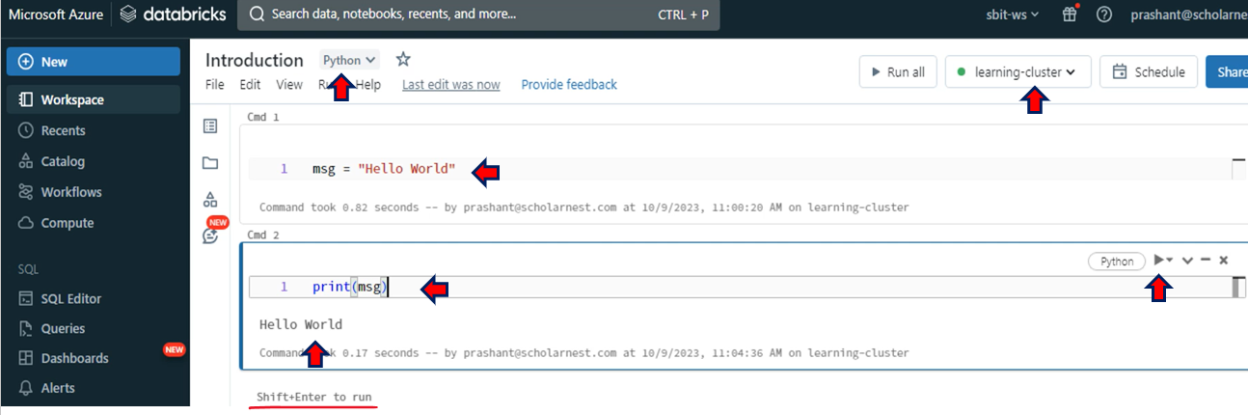

My cluster is already running and I can see the status at the top. So now I can run my code. Let me run this cell. That's all I defined a Python message string. You can see the output just below the cell. Now let me add one more cell and write code to print this message string in the next cell and run it. Then. And you can see the output here. And that's how the notebook works. You can write and run one or more lines in a notebook cell. Then you can write more code in the next cell and run that. This notebook is attached to a learning cluster. You can see it here at the top. So whatever code you are writing and running in the notebook is going to the cluster for execution. Then the notebook returns the output to you and shows it below the cell. Click on this cluster drop down. Move your cursor to the cluster name and see some menu items. So you can see, Detach this notebook from the cluster and attach it to another cluster. I have only one running cluster, so it doesn't show me any other cluster. But in real life you may have multiple clusters such as dev and test clusters, so you can detach your notebook from the dev cluster and attach it to the test cluster. And you can run the same notebook in multiple environments. You also have some other options here. You can restart your cluster, detach and reattach your notebook directly, jump to the spark UI or go to the driver logs.

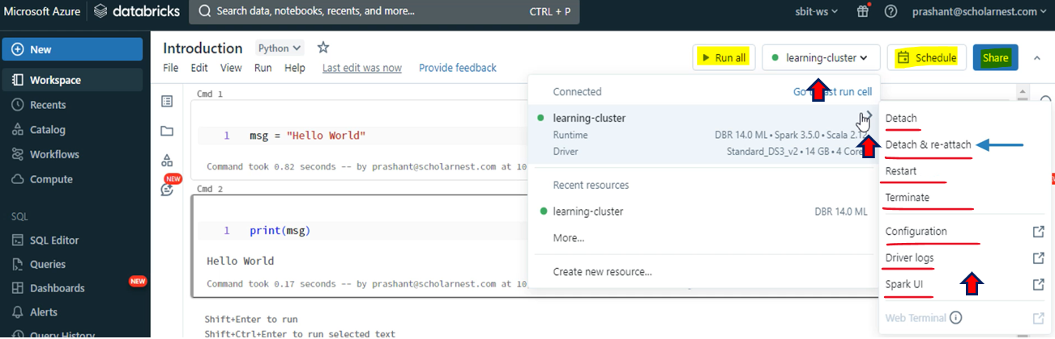

You also have some menu items. Let's look at the file menu. So the file menu allows you to create a new notebook. Clone this notebook, rename, move, delete and some other standard file operations. You also have this excellent export option. So you can export your notebook in four different formats. You can export it as a Databricks notebook archive, Python source file, IPython notebook, and HTML document. The most commonly used option is to export it as a Databricks archive. Once exported, you can import it anywhere again in another Databricks workspace. The import option is available in the workspace menu. Now let's go to the edit menu. The edit menu gives you a standard editing options such as cut, copy, paste of the notebook cells. I often use these find and replace options. You also have some code formatting options here. You can format an individual cell or an entire notebook. You can also set your Python indentation. Let me click. So the default indentation is four spaces. You can change it I like four so I will not change it. The next one is the view menu. As usual, the view menu gives you options to change the visual presentation of the notebook. I have this standard view, but you can switch to results only and see only the results. You can also switch to a side by side view to display code and results. Let's try side by side. Looks good, right? Let me switch back to standard mode.

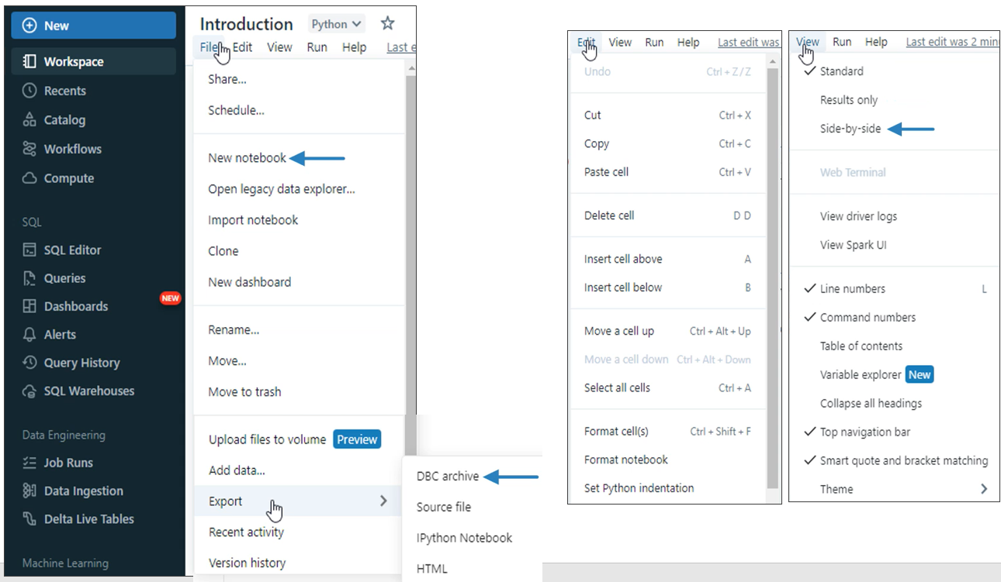

|  |  |
| --- | --- |
| The next one is the run menu. You can run all. Run a specific cell. Run all cells above the current position. Run all below and run only the selected text. The bottom of the run menu gives you options to manage outputs and notebook state. You can clear cell outputs and clear notebook state.  So what is a state? Let's clear the state and output so I can explain it. I created a variable in the first cell. Then I print it in the next cell. But the next cell does not know anything about what happened in the previous cell. Let me run the print message. It throws a name error. Why?  [ See Screenshot Below ]  Because it doesn't know anything about the MSG variable I defined in the previous cell. So I must go back and run the first cell. Once executed, the notebook maintains a state of the commands executed in the previous cells. Now I can return to the second cell and run it without any error. And that's what I mean by state. So you can clear the state using the clear menu. |  |

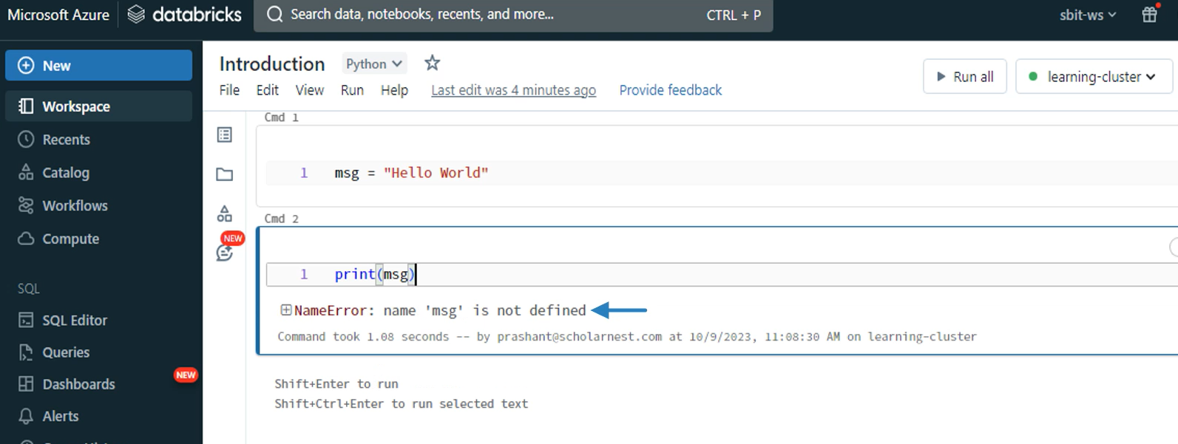

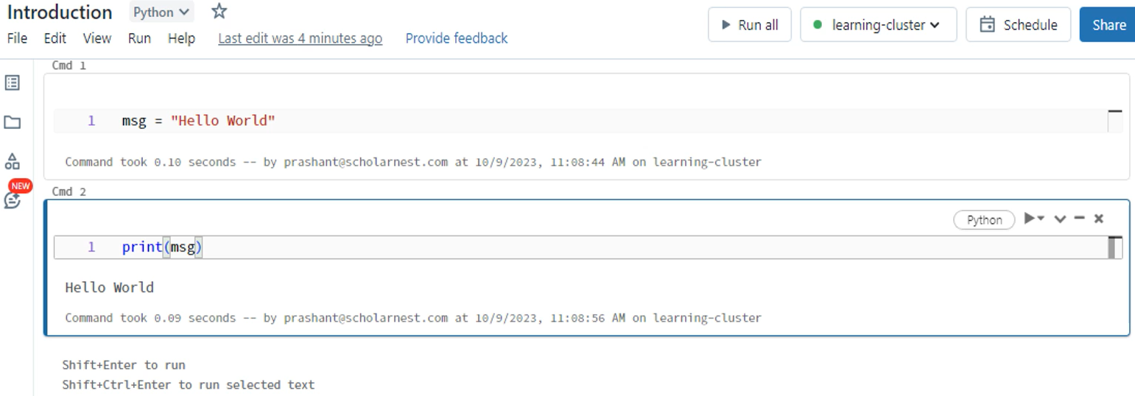

The next one is the help menu. The help menu gives you access to the list of keyboard shortcuts. We have two modes in the notebook. You are in the edit mode when you are in a cell with an active cursor. Press escape and you will come out of the specific cell and it becomes command mode.

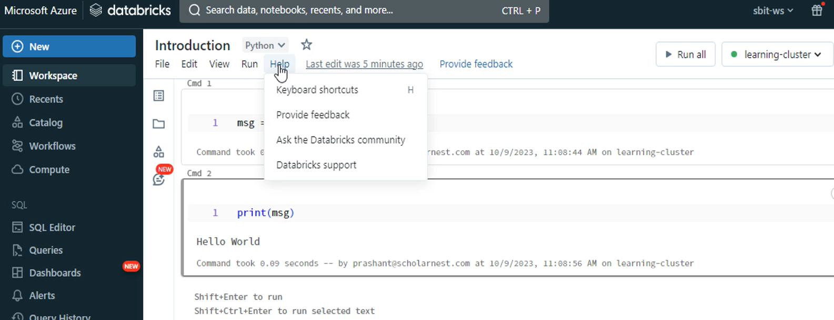

You can see the list of shortcuts here. Memorize some commonly used operations. For example, you can see that shift enter will run commands in the current cell and move the cursor to the next cell. The control enter will run the command but does not move the cursor.

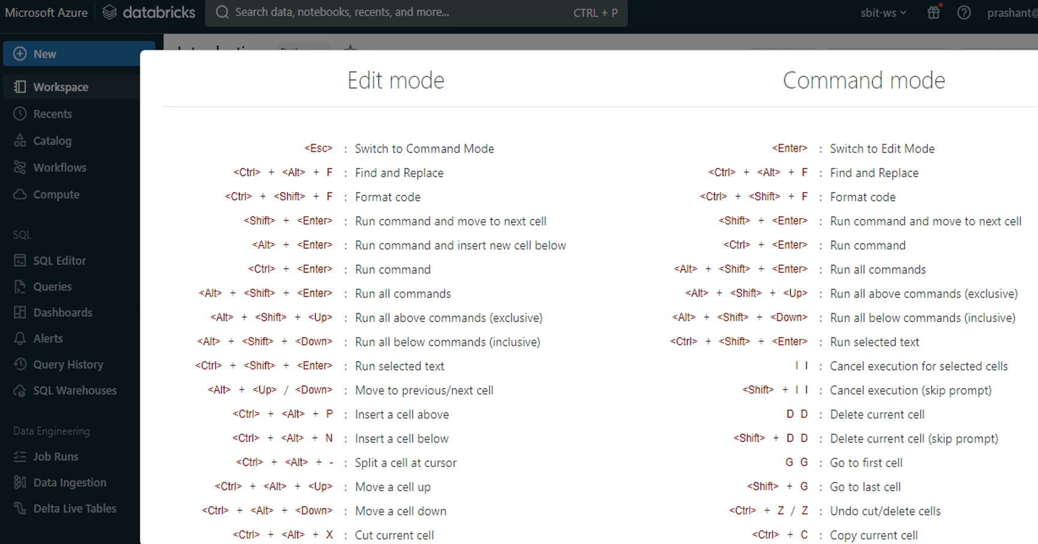

The notebook environment also gives you some additional options in the right side menu. You have this comments option. This one is mainly used in a multi-user environment for adding review comments. For example, you can select some lines of code in the notebook and come back here to add comments for those lines. Other users can reply to the comments.

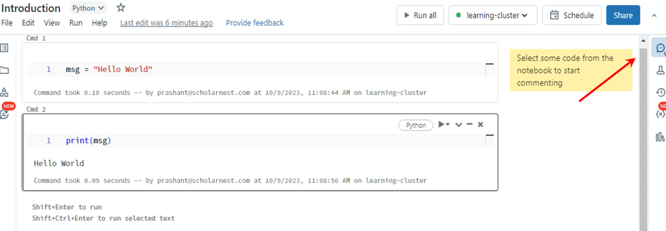

That's a nice feature used over the shared notebooks for review and feedback loop. You also have an experiment menu mainly used by the data scientists. Then you have a revision history, so your notebooks are versioned every time you save them, and the workspace keeps track of the versions. You can return to the older notebook versions to restore old code. You have a variable explorer to debug and see the value of variables in your notebook. Finally, you have Python libraries to see what is installed.

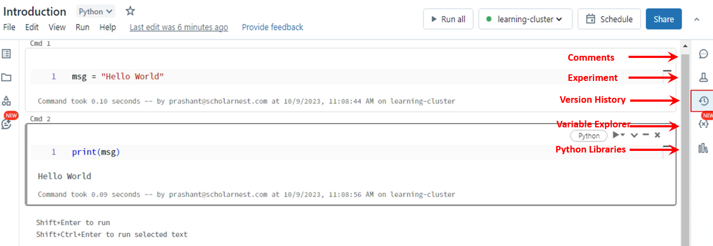

Choose the notebook in the type.

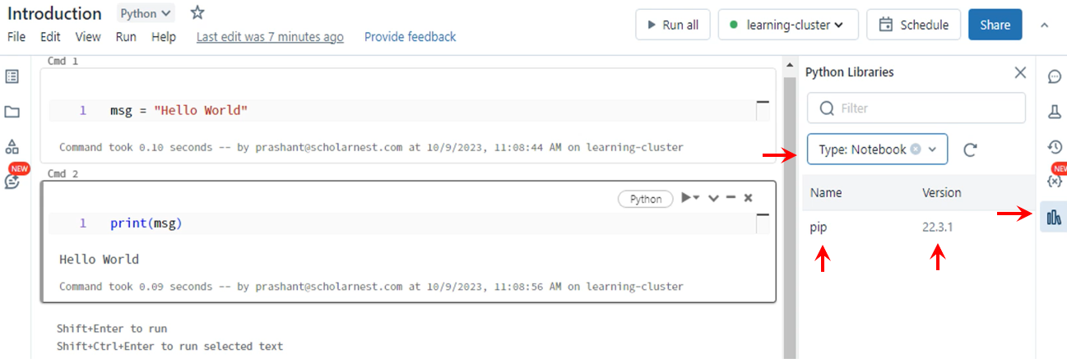

You can see only Pip is pre-installed at your notebook level. Choose the cluster in the type and you will see nothing.

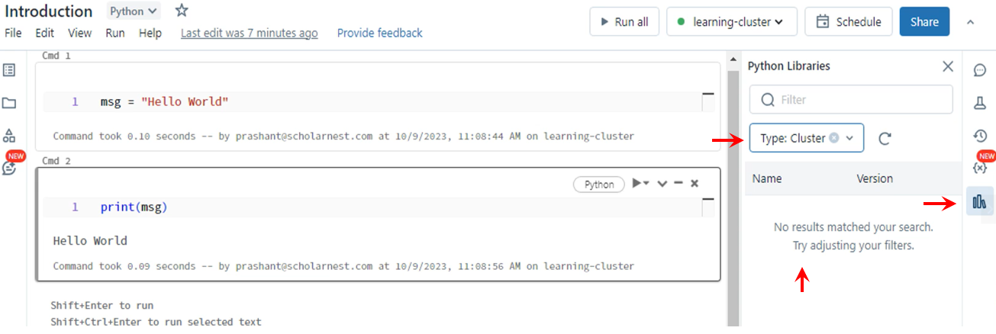

So nothing additional is installed at the cluster level. Now choose the runtime and you will see. A lot of Python libs are pre-installed in the Databricks runtime. If you need anything additional, you can install it at the notebook level using the Pip command in your notebook. You can also install it at the cluster level, so the library is available to all notebooks on the same cluster.

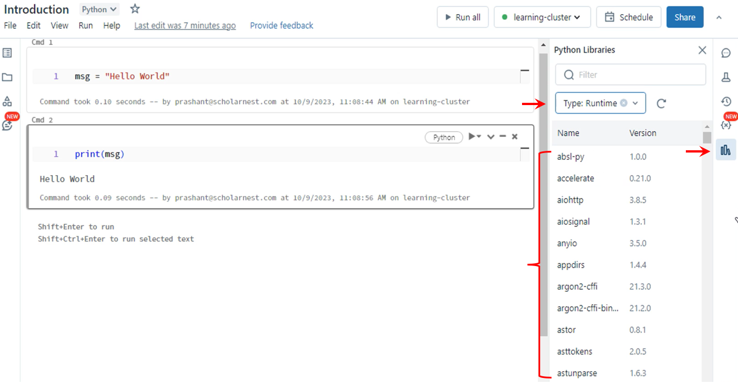

We will learn about the installation of custom libraries later, but you can see what is there from this place. Let's come back to the workspace home page. Click the Databricks logo at the top of the page.

Now you can see a shortcut to your notebook in the recent items, so you can directly jump to your notebook if you want to work on it again. However, you can also navigate to your existing notebook from the workspace menu.

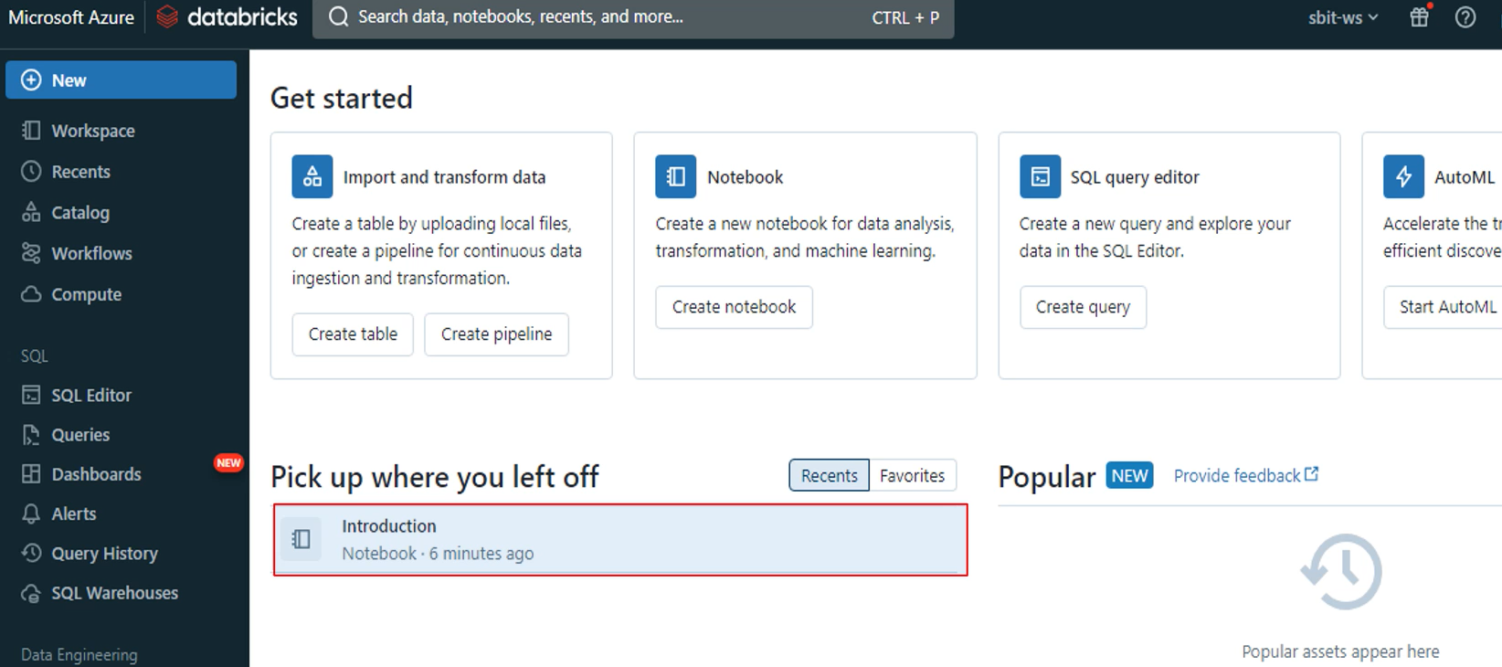

Lets learn the Notebook Magic command. Here is my Databricks Workspace home page. We selected Python as the default language for this notebook. You can see it here at the top. Click that button and you can change the default language of your notebook. But that's not required. We usually choose one default language for the notebook, but we can mix other language codes in the same notebook. I chose Python as my default language because most of my code will be Python and PySpark, but I can also run SQL commands in the same notebook. Databricks offers you some magic commands to do that. The first magic command is percent sequel. Let me show you. Go to any cell to type percent SQL and press the new line. That's all. Now you can write SQL in this cell. My notebook is a Python notebook. So the default language for any cell in the notebook is Python. But using the magic command I can change the language of this cell. You can see that in the cells context menu it shows SQL here. Now you can write SQL expressions and run them.

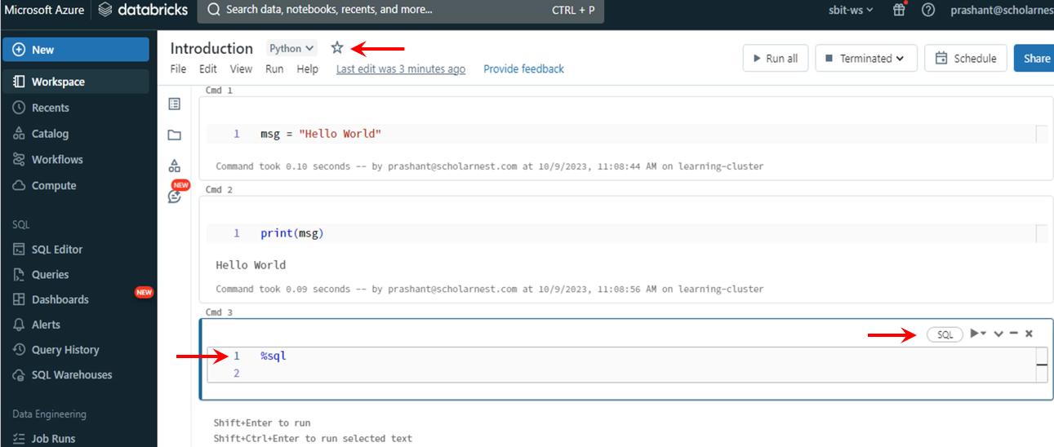

Let me show you. I do not have a database table yet, so I am writing a simple SQL expression. Let me run it. It works, right?

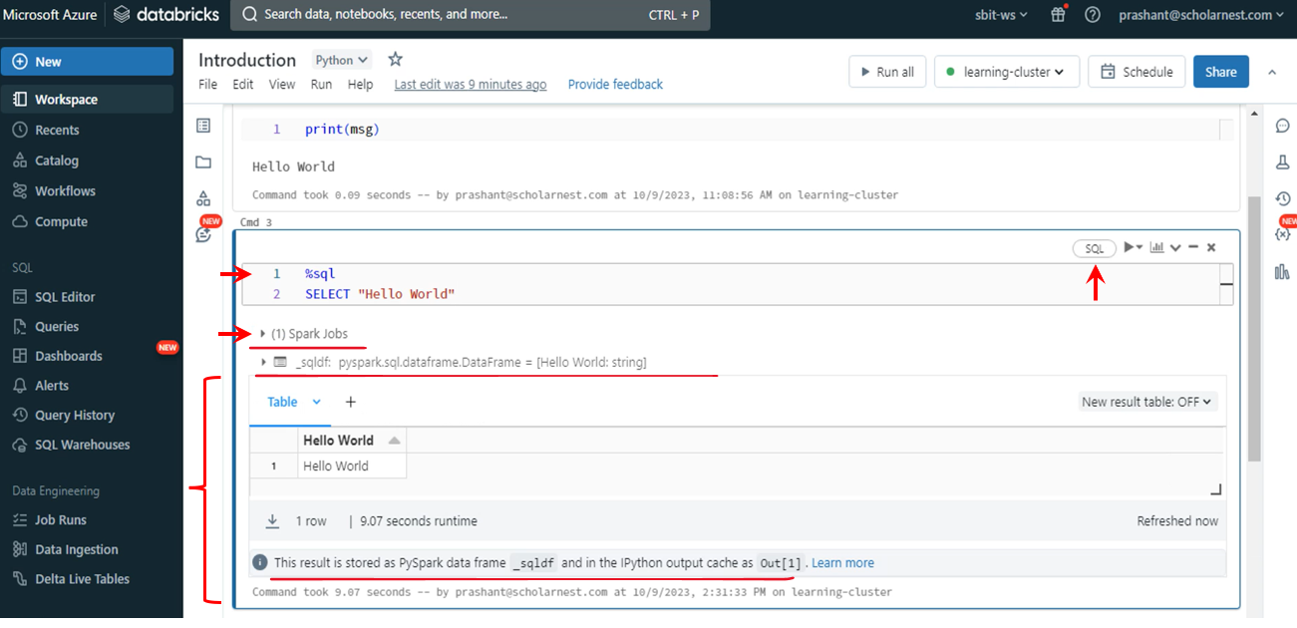

Similarly, you can use the percent Scala magic command and write Scala code. Let's try it.

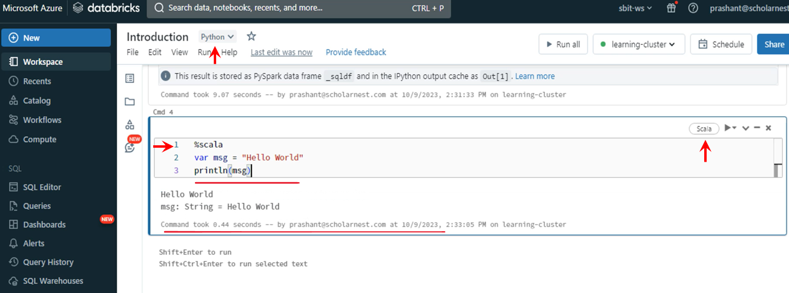

You can also use the percent Python magic command to run Python code, but my notebooks default language is Python, so using the percent Python magic command is not required. But if your notebook is a Scala notebook or SQL notebook, you must use the percent Python magic command for executing Python code. The following magic command is the percent empty command. Go to the first cell and add another cell above the current cell. That's how you can add a new cell to your existing notebook. Use the %MD command, and you can use markdown language to add notes or documentation to your notebook. Let me type something and run this cell.

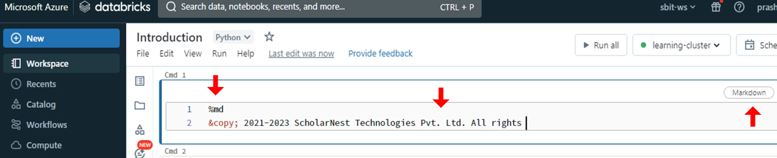

You should learn a little about the markdown language and create excellent documentation within your notebooks. Where to learn markdown language? Just Google for it. You can find some quick tutorials in GitHub documents. The markdown is quite rich, allowing you to add links, images, and many other formatting options to create impressive documentation.

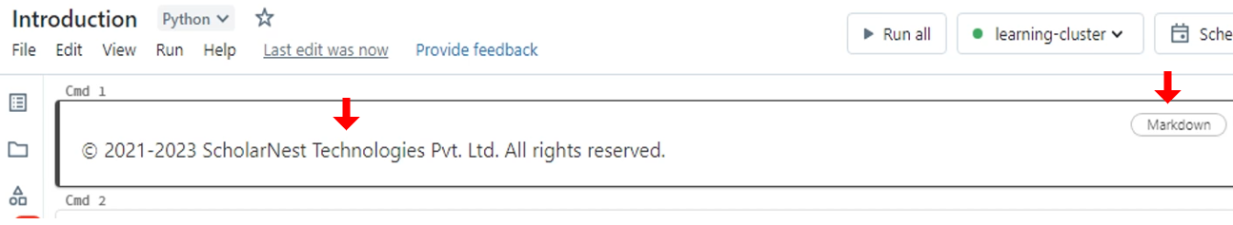

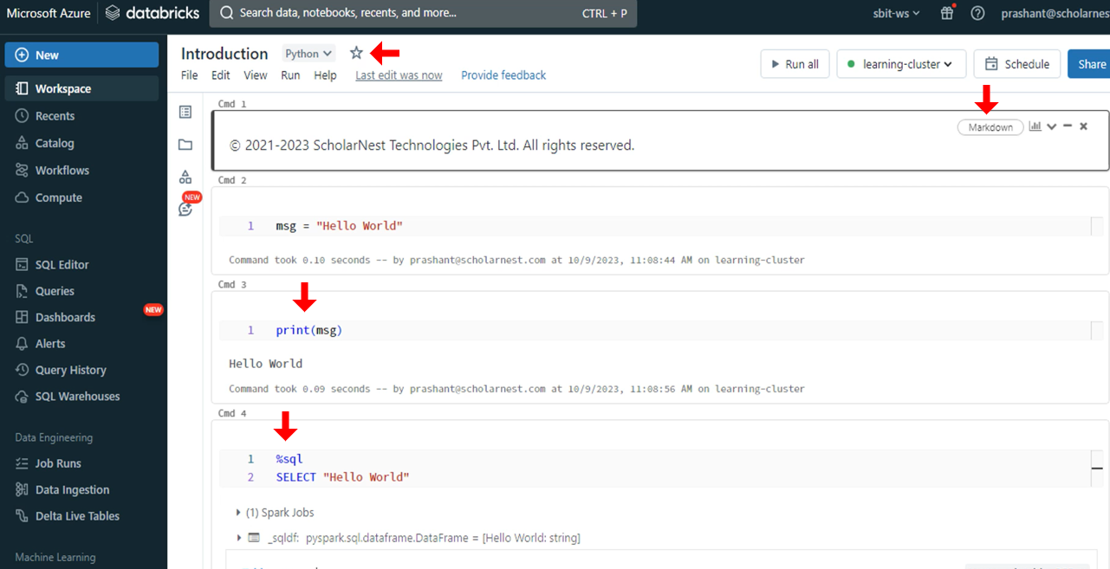

Now let's come back to the last cell. And let me show you a new magic command. The next one is the percent FS command. This one allows you to run some common file system commands. Let me show you the LHS command. Great. Databricks comes with some pre-loaded datasets in your default Dbfs directory. You can see some of those here. Great. You can further explore any of these folders. Let me check the details of the airline dataset. So I am checking the list of files and folders available in the airline's directory. The percent FS allows you to use some file system commands over the distributed file system. That's powerful.

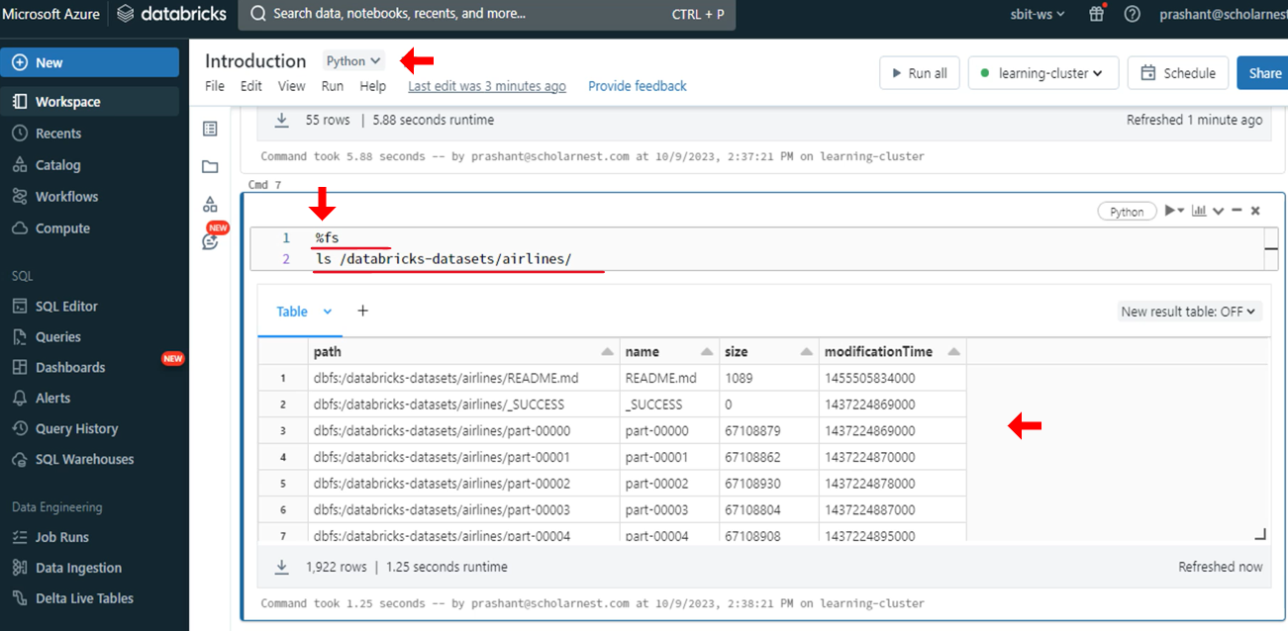

The percent FS command does not offer a complete set of Linux shell commands. But you can also use Linux shell commands. So you can use the percent magic command, which allows you to run Linux shell commands. The tail command is unavailable for the percent FS, but I can use the percent magic.

Great, so we'll learn some commonly used magic commands. Here is the list.

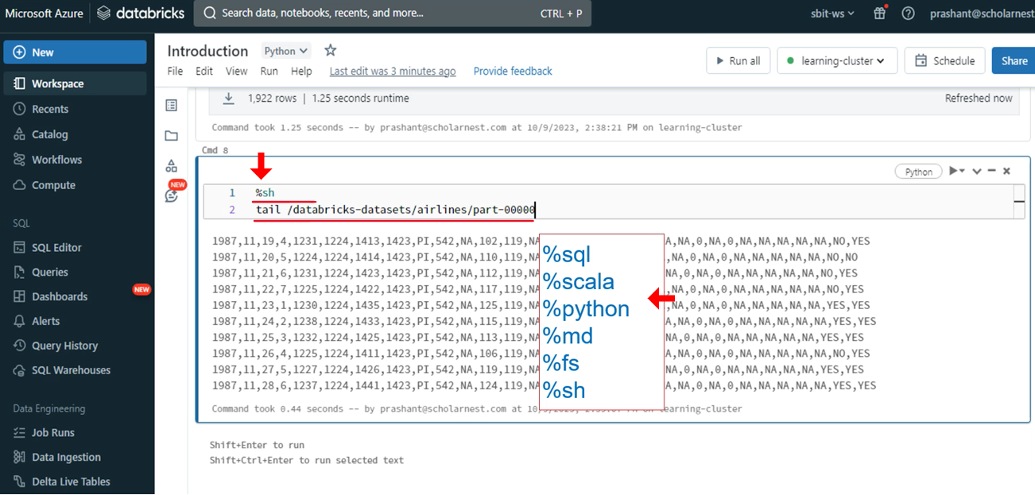

Databricks notebook also inherits a bunch of magic commands from IPython. You can get a complete list of available magic commands using the %lsmagic. Let me show you. So we have a lot here.

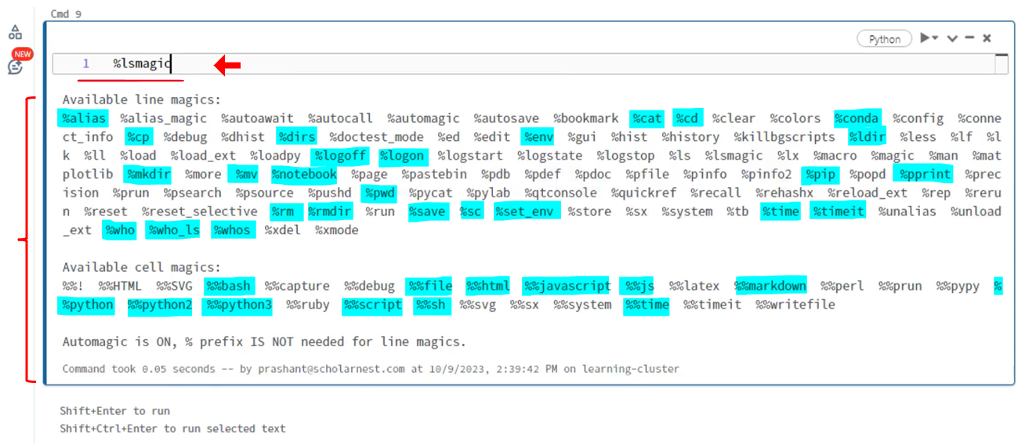

But do not worry about all these magic commands. We will be learning the useful ones in the course, and you can get details of any magic command using the documentation. Magic. Let me show you. You can append a question mark in the magic command and see the documentation.

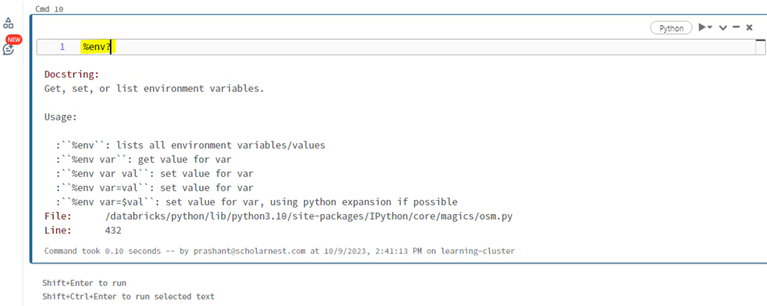

You can also see the source code of the magic command appending double question mark. Let's try one. I can see the source code of the pip magic command.

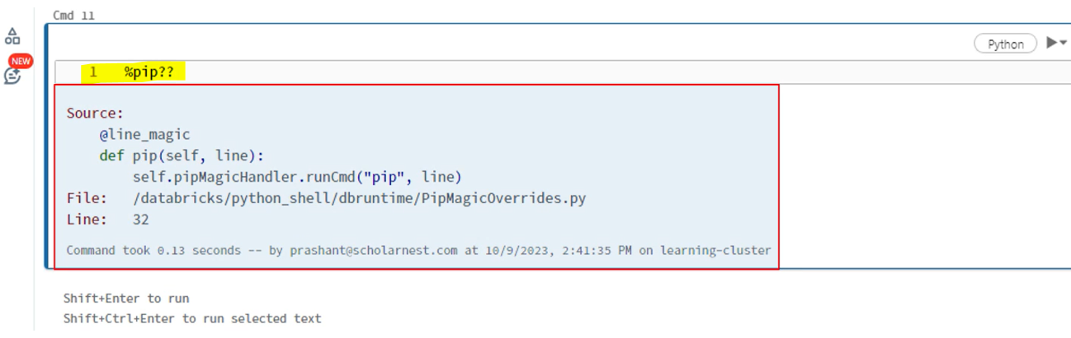

It is a Python function to run the given line of text with the pip system command. Great. So now we have this notebook with multiple cells and we are using multiple languages in different cells of the notebook. You can hit the run all button and run the entire notebook. And that's a powerful feature. You can create a sequence of code blocks in multiple languages for doing things that are easy to do in those languages, and run it as a single notebook.

## Databricks Utilities

|  |  |
| --- | --- |
|  | Databricks offers you the following utilities. Many utilities are experimental under preview and not yet matured for production usage. However, fs, notebook and widgets are the most commonly used utilities. I will introduce you to these and show examples of FS notebooks and widgets. However, the approach for using all these and any other upcoming new utility is the same. You can learn the mechanics of using one, and you will be able to use the others as and when needed.  Here I am on my Azure Databricks workspace. Let me create a new notebook for this lesson. Change the name of your notebook. Great Databricks DB utils is a package that offers you many utilities. Let me show you the list of currently available utilities. Good. So you can see a bunch of utilities listed here. |

Azure Databricks Docs - <https://learn.microsoft.com/en-us/azure/databricks/>

Databricks Utils – <https://learn.microsoft.com/en-us/azure/databricks/dev-tools/databricks-utils>

Filesystem – <https://learn.microsoft.com/en-us/azure/databricks/dev-tools/databricks-utils#dbutils-fs>

Workflow/ Job – <https://learn.microsoft.com/en-us/azure/databricks/dev-tools/databricks-utils#dbutils-workflow>

Secrets – <https://learn.microsoft.com/en-us/azure/databricks/dev-tools/databricks-utils#dbutils-secrets>

Notebook – <https://learn.microsoft.com/en-us/azure/databricks/dev-tools/databricks-utils#dbutils-workflow>

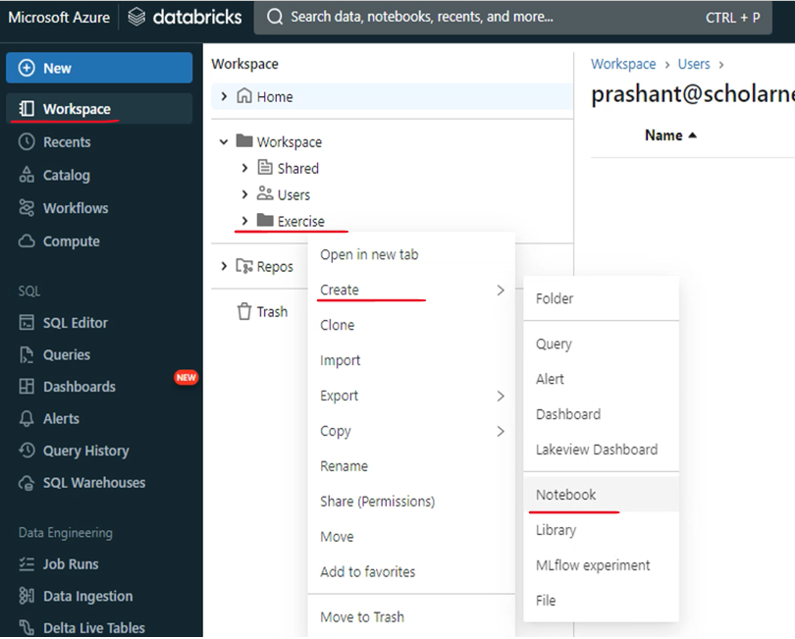

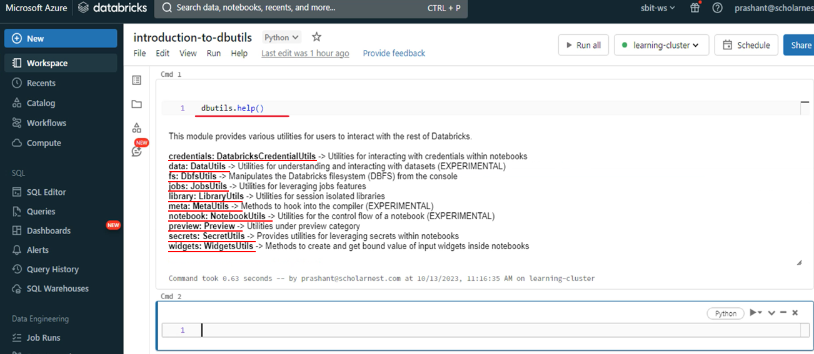

The credentials utility allows you to show user roles and assume a user role within a notebook. The data utility allows you to understand a data set as on date. It only gives you a method to calculate some statistics on a data frame and give you a summary. The PFS utility gives you methods to interact with the Databricks file system. Dbfs. The jobs utility is to interact with the Databricks workflow jobs. The library utils allow you to locally compile an application that uses DB utils. The meta is not for metadata. It allows you to hook into the compiler. The notebook allows you to run a chain of notebook. The preview is for hidden utilities under preview. The secret is for accessing secure credentials from within the notebook. The widget is to create notebook parameters. You can see the documentation of these utilities using these second level help. For example, you can see the list of methods for the FS utility using the FS help.

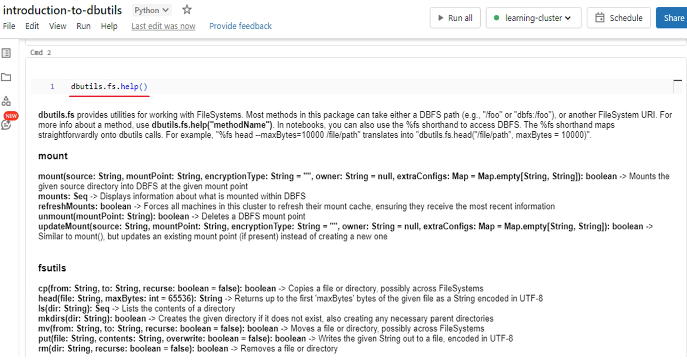

The entire documentation for the PFS utility is listed here. In the same way you can check the documentation for other utilities. You can also get the documentation for a specific command. Let's assume you want to see the documentation for the CP command of the PFS utility. You can see it using the following. So you know how to get help for any Databricks utility.

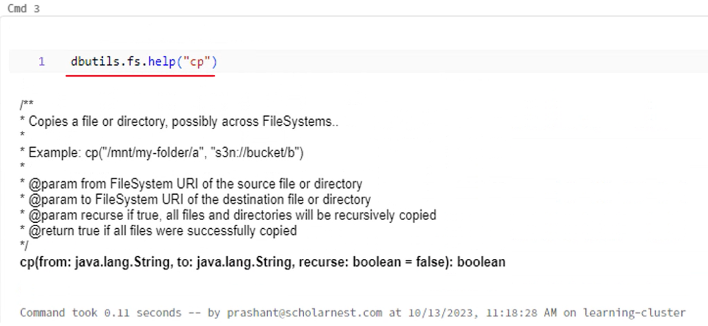

Now let's try some of the most commonly used utilities. The first one is the file system utility. Let's start with the fs utility. The file system utility provides you with methods to perform some dbfs operations. So you can do copy head ls, mkdir mv, put rm and mount operations. If you remember, we used the percent fs magic command in the earlier lecture. Let me show you once again. It works as a magic command. However, this magic command uses Databricks File System Utility behind the scenes, so you can do this same thing using the utility package. The results are the same, correct? They are being displayed differently, but the outcome is the same.

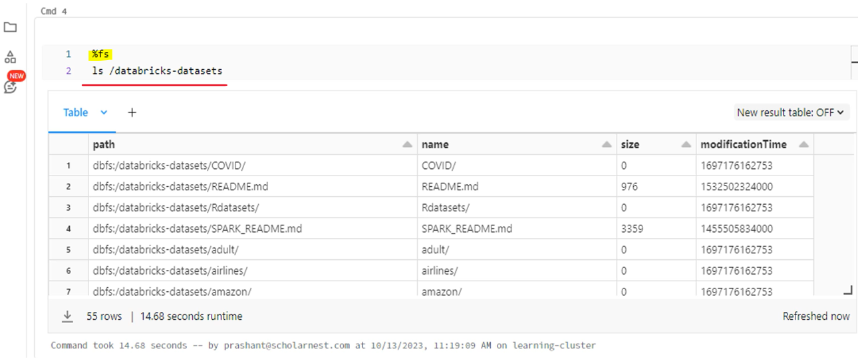

But what is the benefit of using the file system utility package when we can easily use the magic command? The db utils package allows you to use the file system commands in your Python code.

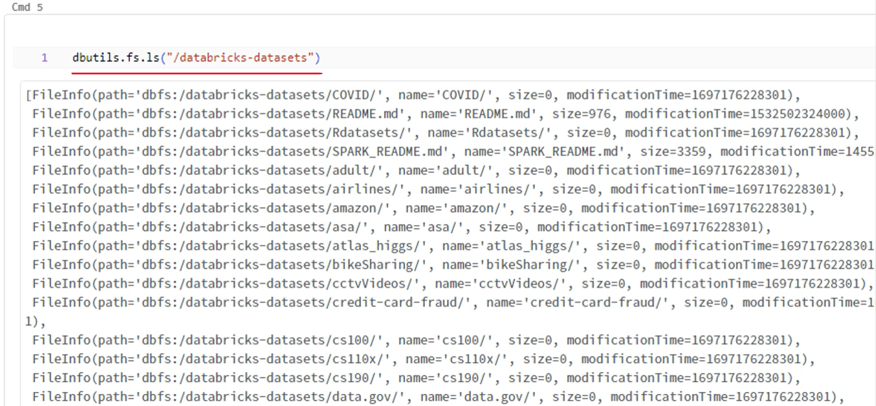

|  |  |
| --- | --- |
| I am taking the list of directories using the utility package and looping through each item. You cannot do these things with the percent FS magic command.  The DB utils allow you to leverage the power and flexibility of a programming language. Most of the file system utilities are straightforward. You have cp head, lz, mkdir, and other usual file system commands. They all behave similar to the Linux commands. |  |

The file system utility allows you to mount a cloud directory into the Dbfs, so you can mount your Amazon S3 or Azure ADLS directories to Dbfs using the FS dot mount function. I will show you the mount later when we need to do that. Now let's look at the next utility. The next one is the notebook utility. Let me show you the help for this same. So the notebook you tell offer you only two command, exit and run. The exit method is used to return an exit code from the notebook. The run method is used to call a notebook from another notebook. These two methods look simple, but they offer a powerful feature. Together, they allow you to design a modular spark application. You can create multiple notebooks, each taking care of one specific thing. Then you can have one main notebook calling the other notebooks. This allows you to create reusable spark code and design a modular application.

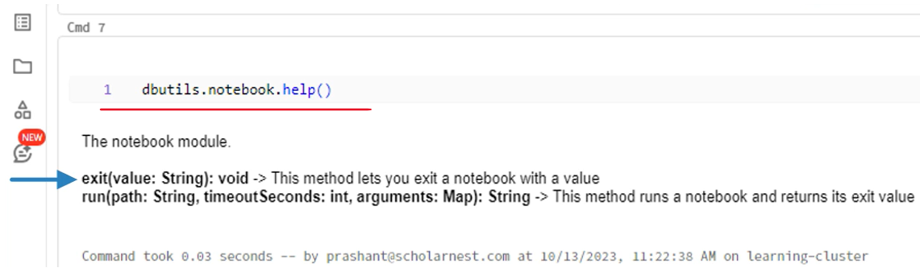

Let me show you how to use these two methods. Let me create a new notebook. Let's give it a name. I call it a child notebook. I will write some code here. Then in the next cell, I will exit from the notebook and return an exit code. Let me run it once and see if things are working.

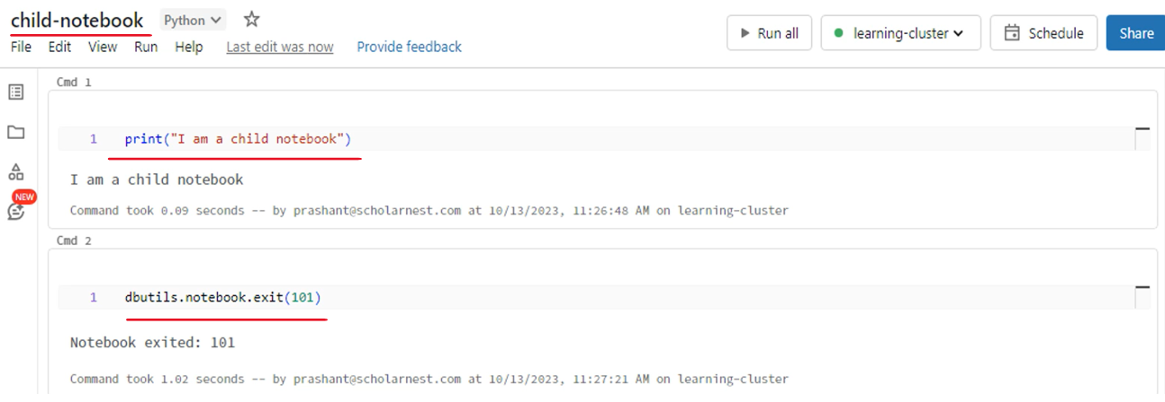

Now I will go back to my first notebook. Let's go to the last cell and call the child notebook from here. The run method takes three arguments. The first argument is the full path of the child notebook. The second argument is a timeout in seconds. I am giving only two arguments here. The third argument is to pass some values to the child notebook. We have nothing to pass yet, but I will show you that feature shortly. So what am I doing here? I am calling a child notebook from a parent notebook.

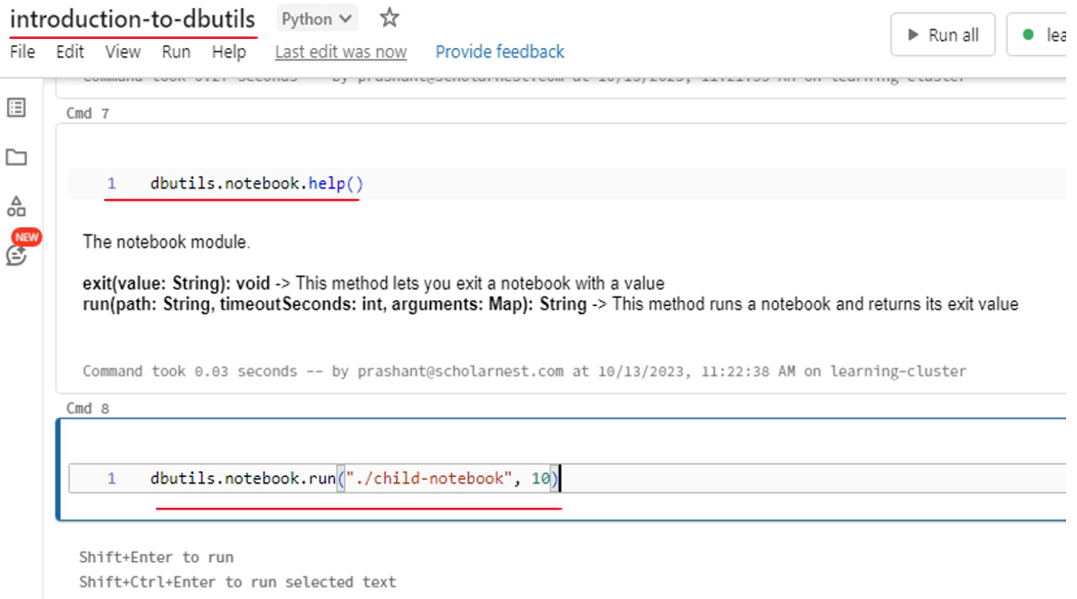

That is a powerful capability and I will teach you how to use it in real life projects. But for now, let's run it and see if this works. Then you can now see two things in the output. The first line shows a child's notebook job. And it is a link. Click that link to see what happened in the child's notebook. The next line shows the exit code. This is the same code that we returned from the child node. Correct.

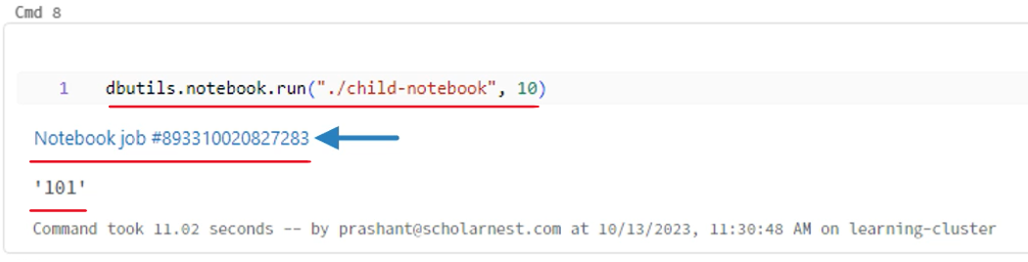

Click the notebook job to see what happened in the child's notebook. Good. So we have the print statement and its output. Then we have this exit statement and the exit code. So everything worked as expected.

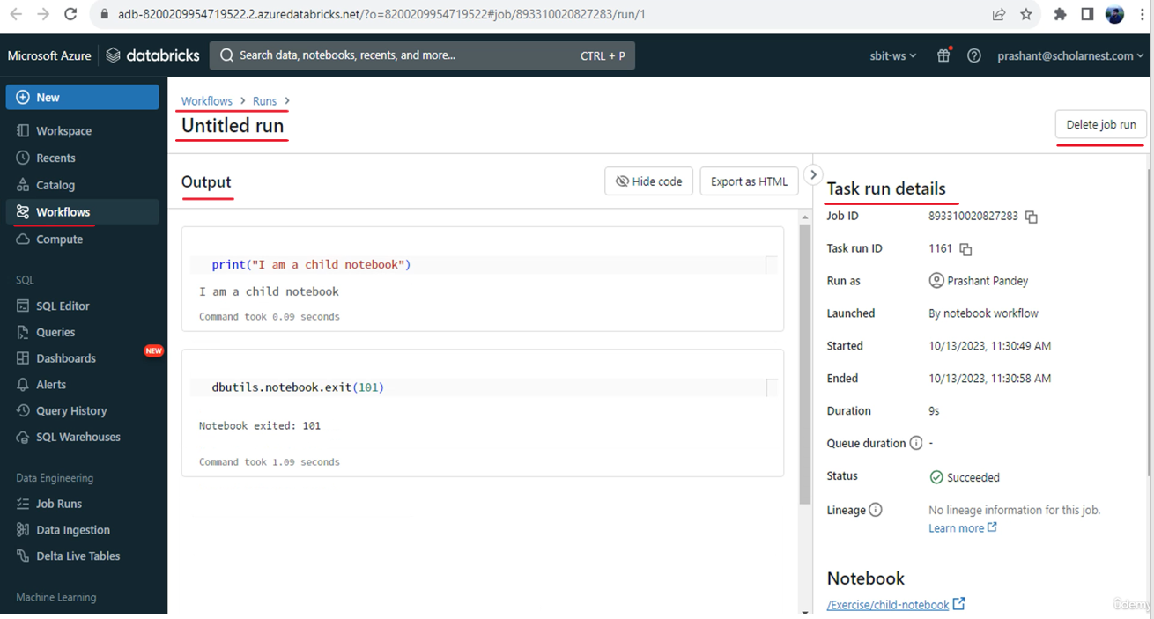

Let me come back to the parent notebook. So you learned about the notebook utility. Now the next one is the widget utility. The widget utility allows you to add input arguments or parameters for a notebook. That's also a powerful feature. It allows you to write a parameterized code. I mean, a code that works for different values depending upon the input parameter. Lets see how to use the widget utility. Let me jump back to the child notebook. Now I will add a new cell at the top of the notebook. Here it is. Before using the widget utility, let me show you the help. So the Databricks widget gives you four methods to add arguments. The most commonly used method is the text method, but you can create combo box, a drop down list, a multi-select argument list in your notebook. Then you have the remove all to delete the arguments from the notebook.

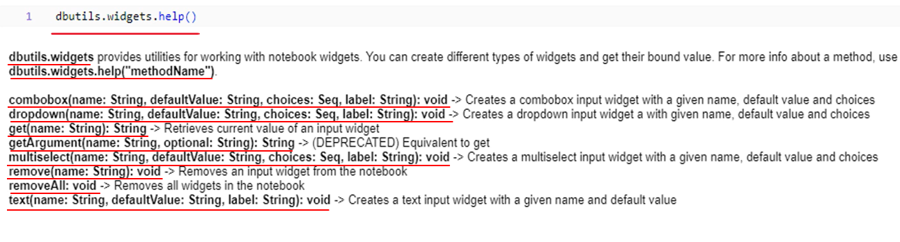

The most important one is the get method. The get method allows you to read the input argument value. Let me give you a quick demo to understand how it works. I will use the text method to create a text argument for this notebook. Replace the help method with the text method. The text method takes three arguments. The first one is the name of the input variable. The second one is the default value. So if no value is given, you will get the default value. Let me keep a null string there so we do not get any default value. The last argument is a label. Running and you will see a text box at the top of the notebook. The label is displayed here and you can type an input value in the text box.

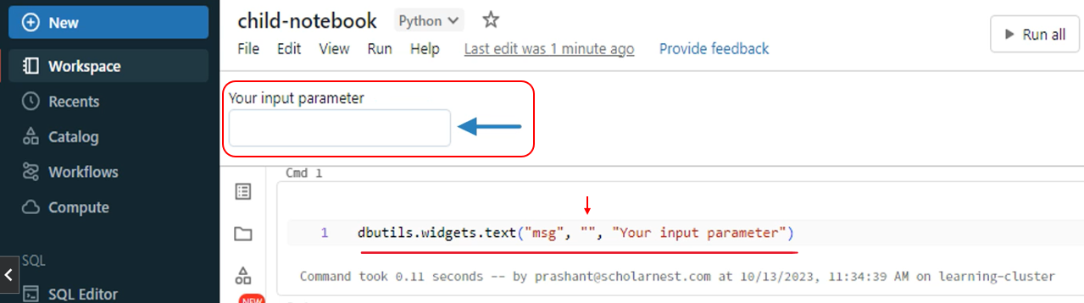

Whatever value we type in this text box will be assigned to a variable in the utility package namespace. You can retrieve the input value using the get method. Let me show you.

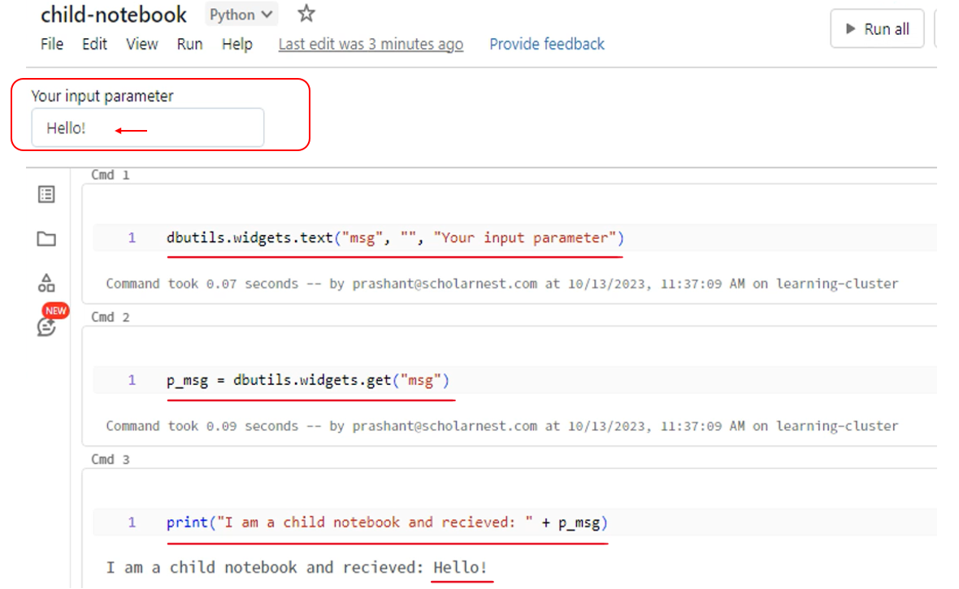

So I retrieved the input value in a Python variable. Now I can use it. Let me show you. So now I will concatenate the input value in the print message. Renamed. But it is not showing anything. It simply says I am a child. Notebook and received. That's all. Why? Because we did not set any value to the argument. The text box at the top is still empty. Place some value in the text box and run all. Now you can see that the variable has some value also printed there. What does it mean? Simple. You can define one or more variable inputs to your notebook, then get them in Python variables and use them in your code for testing the single notebook. You can set the input values in the text box, but the real magic of these input values is seen when you call this notebook from the parent notebook. Let me show you. Go back to the parent notebook. We are calling the child notebook from here, right? But the child notebook now accepts one argument. So I can pass the argument value from here.

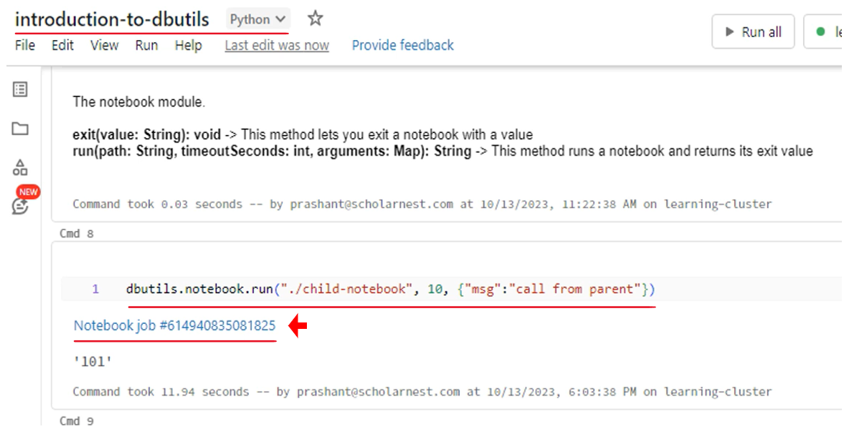

The argument list goes as a set of key value pairs. Even if we have a single argument, we must send it as a list of key value pairs. Let me run it. Completed. Let me hit this child notebook job and see what happened. Great. You can see this output string here. We got the value that we passed from the parent notebook right. Great.

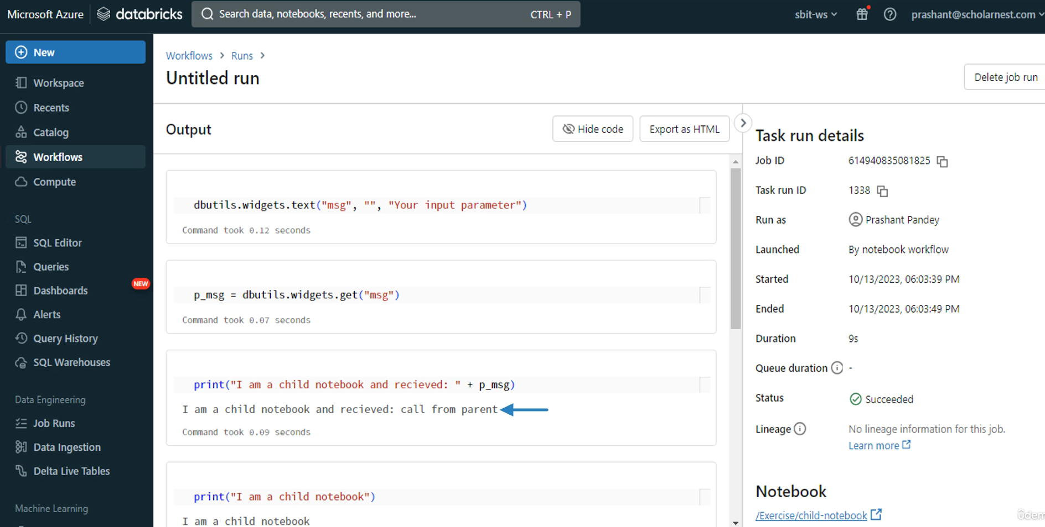

Databricks offers you many utility modules. Some of them are still experimental and not yet mature. However, we have three most commonly used utilities that we will be using in our course and project.

|  |  |
| --- | --- |
|  | You can use file system utilities to read and interact with your Dbfs file system. You can bring the values from your file system to Python variables and use them in your notebook. Notebook utilities allow you to chain your notebooks. You can call one notebook from another notebook. These notebooks can also return an exit code to check whether the notebook calls succeeded or failed. Widget utility allow you to add parameters to your notebook, and you can set values to these parameters while calling them from the parent notebook. |

## Working with the Databricks File System

|  |  |
| --- | --- |
| The next important piece for a data engineering project or data lake project is access to the data. How do you access your data? Data most likely sits into the directory. So in this section we will try to understand the data directory structure in Databricks Cloud Platform.  Basically, in Databricks Cloud Platform, data directory is available to us through the Databricks File System Dbfs. We call it Dbfs Databricks File system. So in this section I'll give introduction to the Databricks file system. We will try to understand what it is. And then we will go ahead and try to learn how to use the Databricks file system, how to use or how to access the Databricks File System root directory, and then how to create subdirectories and files and folders within the Databricks file system. |  |

Then in the final step, we will try to learn how to mount or map your cloud data storage directory or cloud data storage infrastructure with the Dbfs so that you can have proper access to, storage system in your cloud. So we are in the Azure cloud. So we will learn how to mount Azure Data Lake Storage or ADLs to Dbfs and gain access to the cloud storage system.

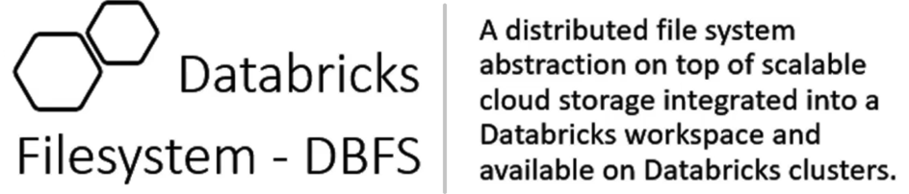

|  |  |
| --- | --- |
| So what is Databricks File system or what is Dbfs? A Dbfs or Databricks file system is a distributed file system abstraction on top of scalable cloud storage integrated into Databricks workspace and available on Databricks clusters. That's how you can understand but what exactly it means in very simple terms.  Databricks File System is a file system, a virtual file system, or file system abstraction that allows you to access your cloud storage like a directory where you can create directories, subdirectories, files, and keep your data there. |  |

|  |  |
| --- | --- |
|  | Now, next thing that I want you to understand is, we already saw Databricks platform architecture. We know when we create a workspace, Databricks will launch a control plane. So for each Databricks control plane, by default, Databricks will initially create one dbfs root directory, right. It will create a dbfs storage. And it will create a storage account in your, cloud provider.  Basically, we will be using Azure. So it will create a storage account in your Azure cloud and mount it, map it, make it available through the Dbfs by default. So usually we call it Dbfs root directory for every workspace. It is available by default. We can store data in this default root directory. We can create subdirectories. We can create files. We can store data here. But it is not recommended to use the default dbfs root directory for storing your data because of many reasons, and you do not have full access or full control on this storage account because it is automatically created by Databricks.  So basically what we do, we create a separate storage account in our Azure cloud and create a root directory there and then mount that root directory separately. We and preferred to use that we will learn all that.  But at this point I wanted to make sure you understand that with every Databricks work space, there is one dedicated default storage account created behind the scene, which is mapped to the Databricks file system, and it is known as Databricks Root Storage or Dbfs Root Storage File System. And you can access it for storing actual data, or for your own purpose or for your project purpose. You are most likely to create a separate storage account. |

|  |  |
| --- | --- |
| Databricks will automatically create a storage account in your cloud and map it with the Dbfs as a dbfs root directory. I talked about this, so let's try to see that. Where do we have the storage account for my workspace and how to access the Dbfs file system that storage layer from my workspace. So let me switch to my Azure portal. So. So here is my Azure portal.  If I try to look at all resources, I'll see a lot of things here. This is the Databricks workspace resource that I created. I created a Databricks workspace. Let me sort it by type and I will see one storage account. So this is Azure Storage account, already created by Databricks for my Databricks workspace. if you look at the resource group name, it says Databricks Hyphen RG, which is my resource group name, hyphen Databricks course, AWS, which is my workspace name. And then some other text added automatically there.  So for every workspace, Databricks will create a storage account in your Azure cloud and make it available that storage make it available as a Dbfs root. So let's go to my workspace and try to learn how to access that. Dbfs root storage. |  |

So I'll go to my Databricks workspace. Launch it. And. Try to access it. So I already have a running cluster here. if you come to compute menu, you will see I already have a learning cluster which is already running here, so I don't need to create a cluster for running my notebook. I'll attach my notebook with this cluster and execute some code. So if you don't have, you can create a cluster and then come to the exercises.

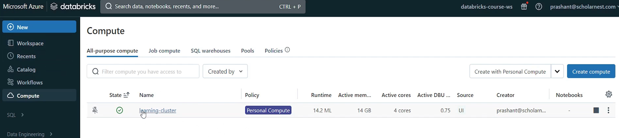

In my home directory, I have this notebook set up for you to give a demo about Databricks File system.

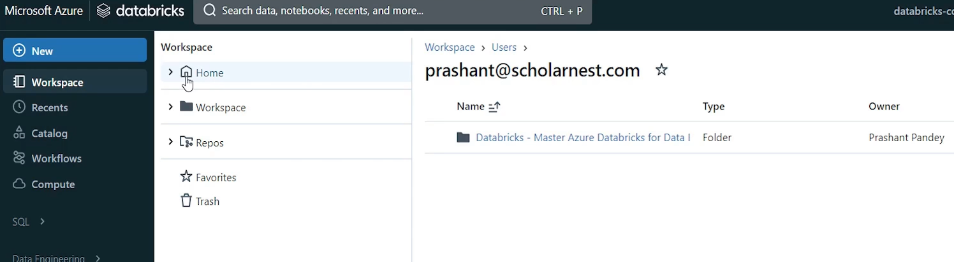

So first thing, what we want to do is to show the list of directories in the dbfs root.

We already learned that with the new Databricks workspace, Databricks will create a storage account in the cloud and make it available as a dbfs root. So how to access that? You already learned? Possibly. Um. Percent of his magic command. So that's how we can access File system or Dbfs file system. And, to access Dbfs file system root, you should be using Dbfs qualifier and then root directory and simply run it. Okay, I forgot the RLS command. So percent FS is the magic command and RLS is the list command for this root file system Dbfs root directory.

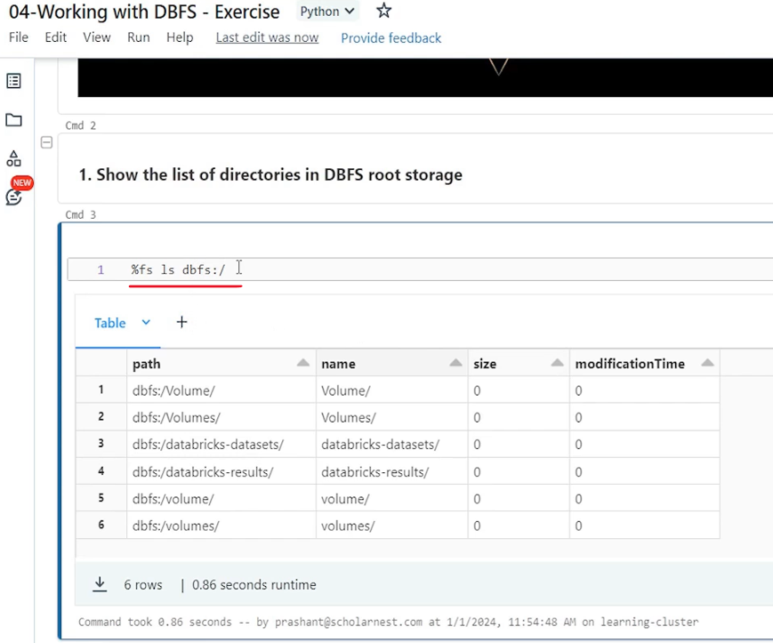

And you can see what all the directories are already created in the root directory. a lot of things are there. These are mostly default root directories created by Databricks itself to store some kind of configuration and other things by the Databricks itself. We are not supposed to use this dbfs root directory for storing data or for our project purposes because, that goes into the default storage, account here created by the Databricks workspace.

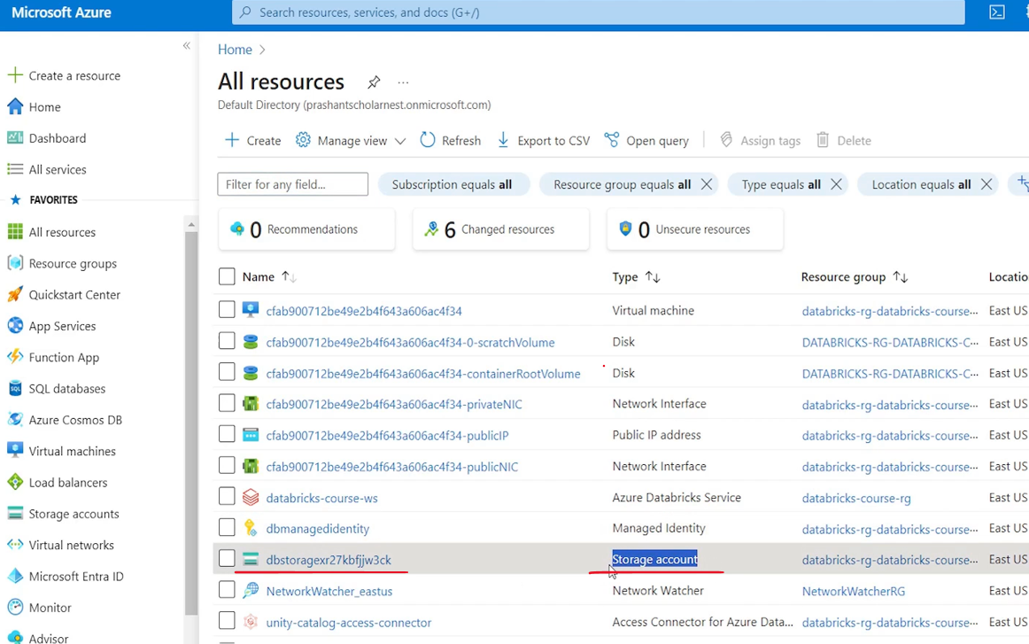

All everything that we store, goes into this storage account, and we don't want that because we don't have, proper access or control over that storage account. So we will learn how to create our own storage account and bring it to Dbfs so that we can use it. But how to access the Dbfs root? You can access it using Dbfs colon slash and use, file system commands. Like percent of vessels. Next thing that I want to explain is that you can access, any subdirectories. Also inside the root directory, for example, we have this sub directory here. So you can use it access the sub directory also and give the subdirectory name and you can access the subdirectory. Basically Databricks data set is a sample data set directory automatically, made available to all work spaces. So you can see a lot of sample data directories inside the Databricks data set. in a typical case we should be accessing the dbfs directory subdirectories or root directory using the Dbfs file system qualifier. But that's not mandatory. If you don't use the file system qualifier, you can simply use it like this.

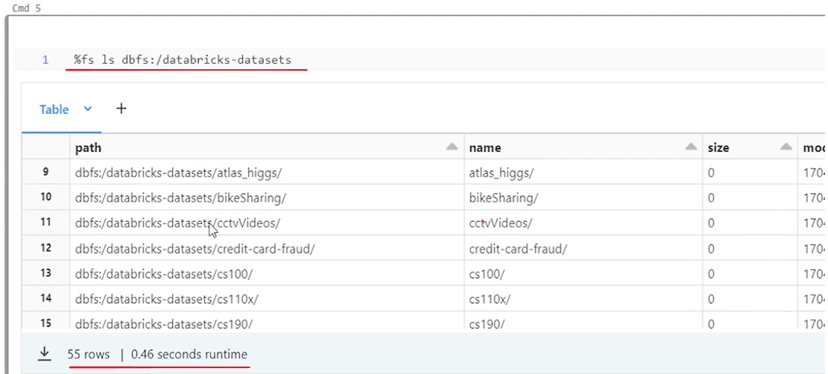

Start from the root and then go inside any subdirectory. And it works. It works because Databricks by default assumes that if you are not using any file system qualifier, you are using Dbfs because Dbfs is the default file system for Databricks, so you can use it that way. Do we have any other file systems for Databricks workspace? Yes we have. Let me show you. You can use file colon and access the root.

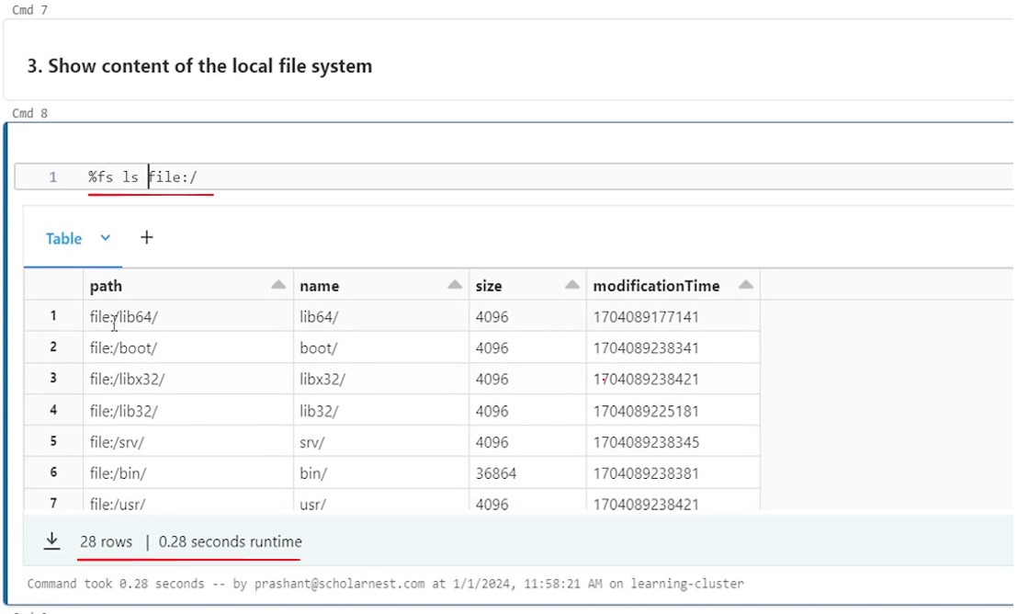

So file colon is another file system which is available in Databricks workspace. that allows us to access the. Local file system of the driver machine. So you can see file:lib64/boot blah blah blah. All these directories, these are basically directories on the driver machine, the local file system of the driver machine. So you can see the um. Other file systems. Also, if you have made it available by default, Databricks brings Dbfs and local file system of your driver machine.

We also have one more command file system command called mount. So if you run the %fs mounts, you will see all the, subdirectories that are mounted over the. Root directory. In fact, root directory is also mounted. And then on all the subdirectories that you see inside the root directory are also mounted in some way by Databricks. So basically root directory is mandatory. This root is mandatory. Dbfs root is something that Databricks Workspace will automatically create.

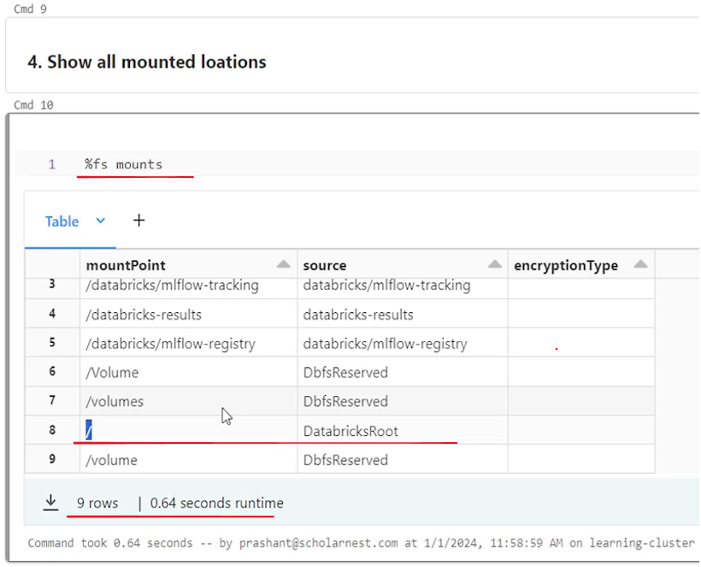

And then for keeping our data or for using something for our project, we are supposed to create a separate directory which we can mount on top of the root directory, Dbfs root directory, and then use it for ourselves.

## Mounting ADLS to DBFS

Basically, I'll quickly recall this architecture.

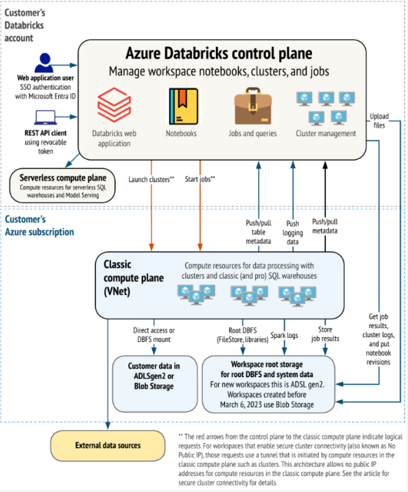

We learned that Databricks workspace is known as control plane. We can access it through the web UI. And for each workspace Databricks automatically creates a storage account behind the scene in your cloud account and map that storage account to Dbfs too. Databricks file system as the dbfs root. But we are NOT supposed to store our data or project reserve resources in the dbfs root. The idea is to create a separate storage account, maybe using ADLS Gen 2 or a Azure Blob storage, and then mount that additional storage account to the Dbfs root. And then we can use our own storage account, which is in our control to store data or other project resources. So let's try to learn that step by step process for doing that. So for creating storage account in your Azure cloud, you have to log in to your Azure portal. For mounting that into Dbfs, you have to come to the Databricks workspace and we can mount it from the Databricks workspace. So there are two parts of this activity. Part one is creating a storage account in Azure Cloud. And then part two is mounting it in Dbfs. So part one we can do using your Azure portal and part two which we can do using your Databricks workspace. So I have already created, a notebook to document all the step by step process. So let me go to that notebook and show you that. Creating your Dbfs mount for data storage is basically a five step process. The first step is create ADLs Gen 2 storage account in your Azure. Create storage containers in your storage account and then create Azure Service Principle and Secret. So basically Azure Service Principle is a service user account. And secret is the password for the service user account. So we create a user and password and then grant access to the service principle for storage account. So we create a user account kind of service account create password and give permissions. For that user to access the storage account and storage container.

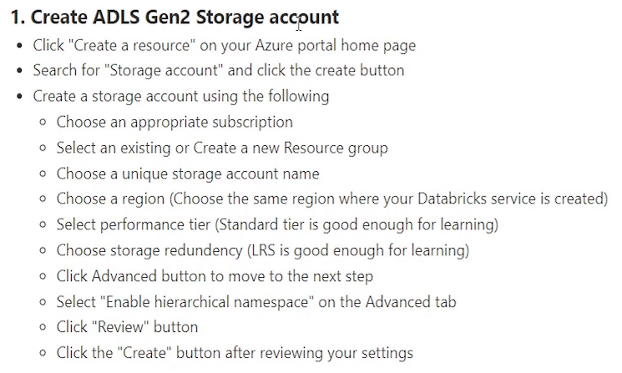

And once all this is done, we are done from the. Azure cloud side. And then finally we come to the Databricks workspace and mount the storage container so that it can be brought to Databricks root directory. So let's go through all these steps one by one. create ADLs Gen two storage account is the first step. So go to your Azure portal and click create a resource on your Azure Portal home page. So we come here create a resource. And then next step is to search for a storage account. So we want to create Azure Storage Account Resource. So search for storage account and you will see a storage account box here.

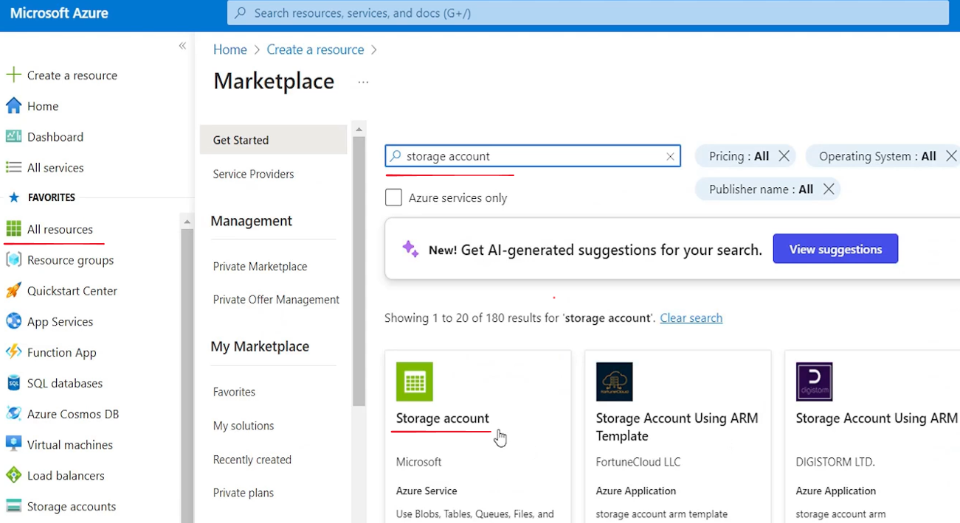

Hit the Create Storage account Button. And like any other service creation in Azure, we have to go through various. Tabs for defining lot of things and create the resource. We'll go through it. So first thing you have to choose your subscription. That's your billing account. You have to choose your resource group. Where do you want to group your resource? I'll go with the existing resource group databricks-course-rg so that everything that I'm creating for this course is grouped under the same resource group. And then you can give a storage account name. So storage account name is little critical. The name must be unique across all existing storage account names in Azure. Globally. It's not only in your project or in your account. So storage account name must be unique in the Azure. So let's create one storage account. Let's see if I get the storage account name. So that’s already taken. Let's add something else.

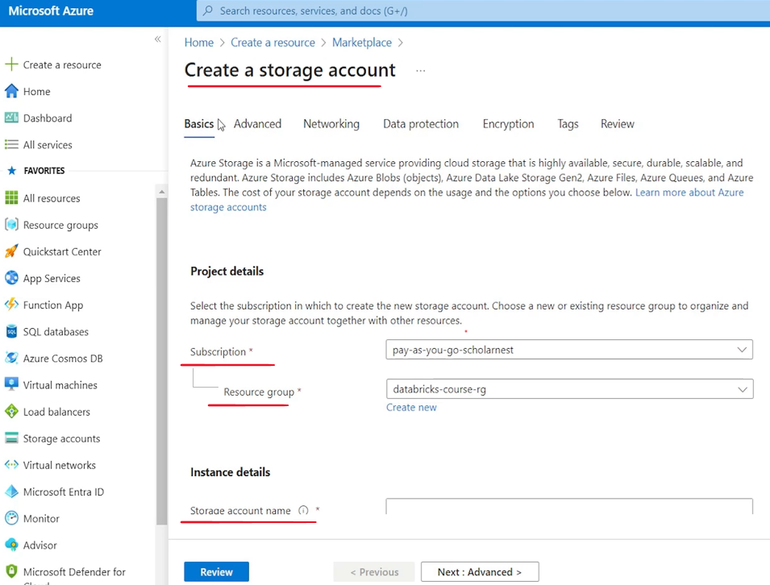

We'll choose the region. In which region? Cloud region. I want to create this storage account. It should be always the same region where you created your workspace. So I created my workspace in East US. So let's go with the East US. We have two performance tiers for our storage account standard and premium. So standard is general purpose V2 account. And premium is recommended for scenarios that require low latency little fast storage account. We can go with the standard for now. It's straight forward and then we have to choose redundancy level. So if you look at it, there are various redundancy level and the lowest is locally redundant storage and highest is geo zone redundant storage. Basically it is to define how fault tolerant your storage is. So what happens if your storage server goes down? Do you have a backup somewhere else and all that? So for now we can go with the locally redundant storage. That's enough for the demo or for our experiment or learning, but for your project, you will choose the appropriate one.

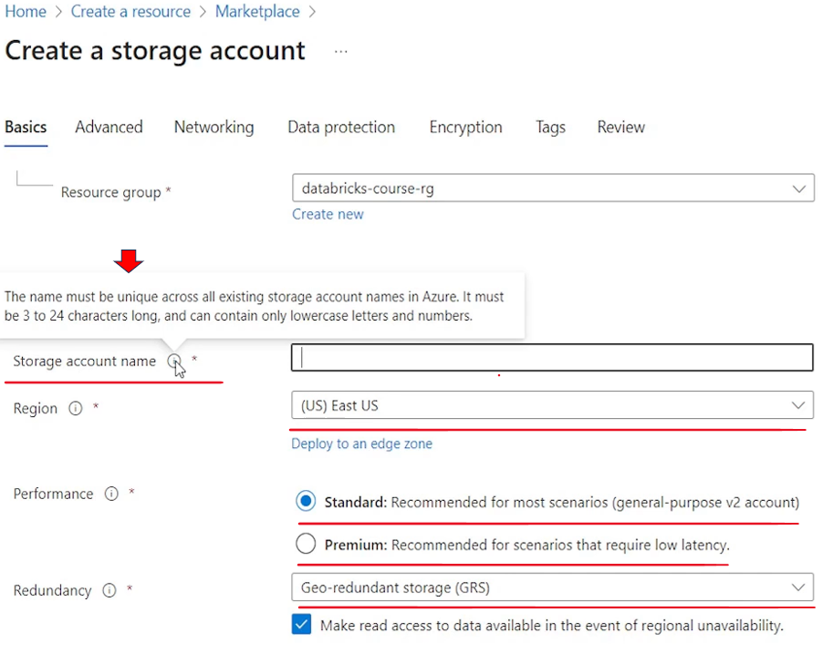

Let's go to the advanced level. And in the advanced level we will come down, look for enable hierarchical namespace and choose this. So basically hierarchical namespace complemented with. Data lake storage Gen 2. So we choose the hierarchical namespace so that we are choosing, Azure Data Lake storage Gen 2, that's the recommended one. The Azure Data Lake Storage Gen one or Azure Blob storage is not recommended for for data storage or for data lake usage. It is ADLs. Gen 2 is specifically designed and optimized for the data lake storage purpose. So we want to use this. And that's all rest all we can go with the defaults.

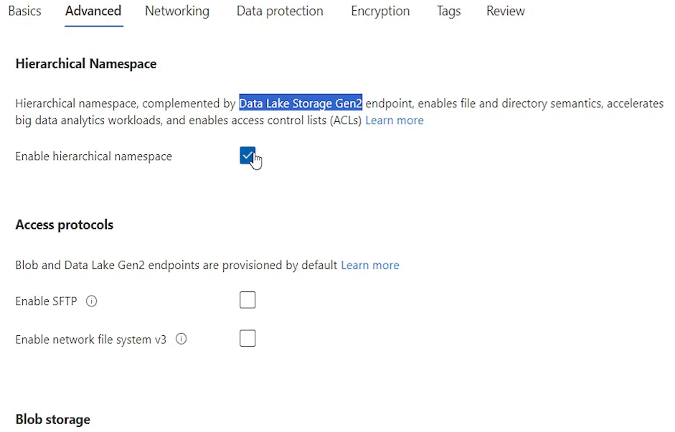

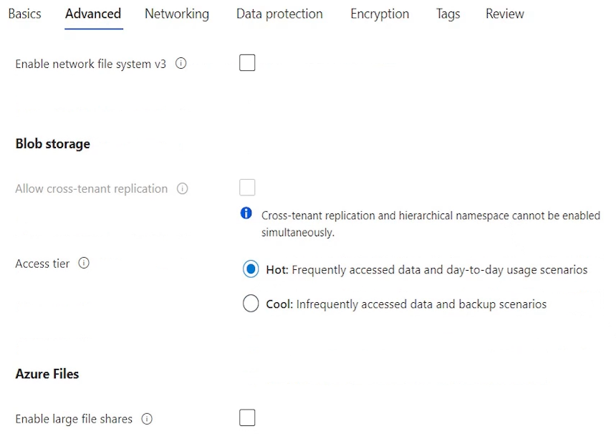

There are many other tabs here you can go and define a lot of other things, but for now, this is enough. and we can hit the review button. Azure will review our configurations, validate it, and once validation is passed, you can create it.

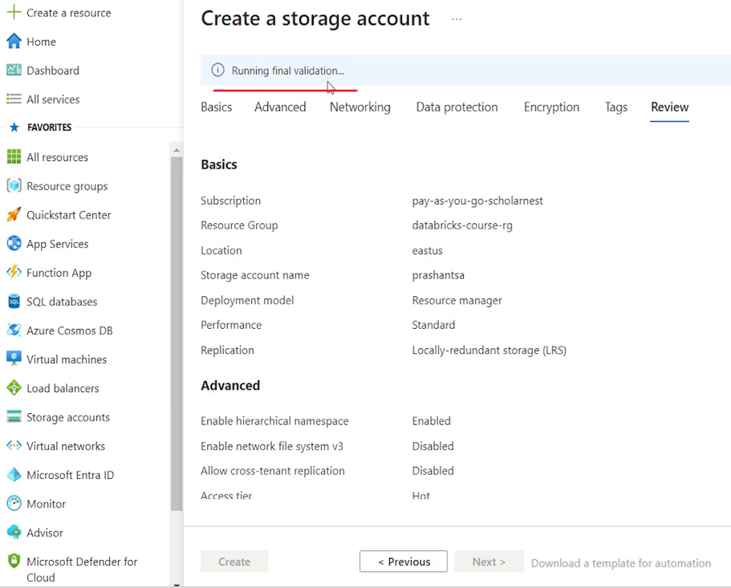

So let's hit the create button. It might take couple of minutes to create a Azure Storage account for us. So let's come back to our notebook and see what all we have finished. So create a storage account using the following steps. Now choose appropriate subscription. select an existing create resource group. choose a unique storage account name. Choose a region. Select performance tier. Choose storage redundancy. LS is good enough for learning advanced button to move next and enable hierarchical namespace review and create. So we have done all that. So we've basically finished step one.

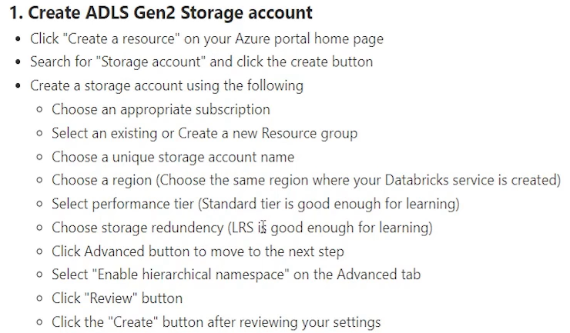

We created a storage account.

The next step is to create a storage container in your storage account. So let's come back and try to do that.

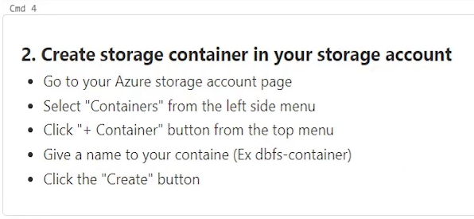

My storage account is already created. I can hit the go to resource button and it will take me to the storage account resource page.

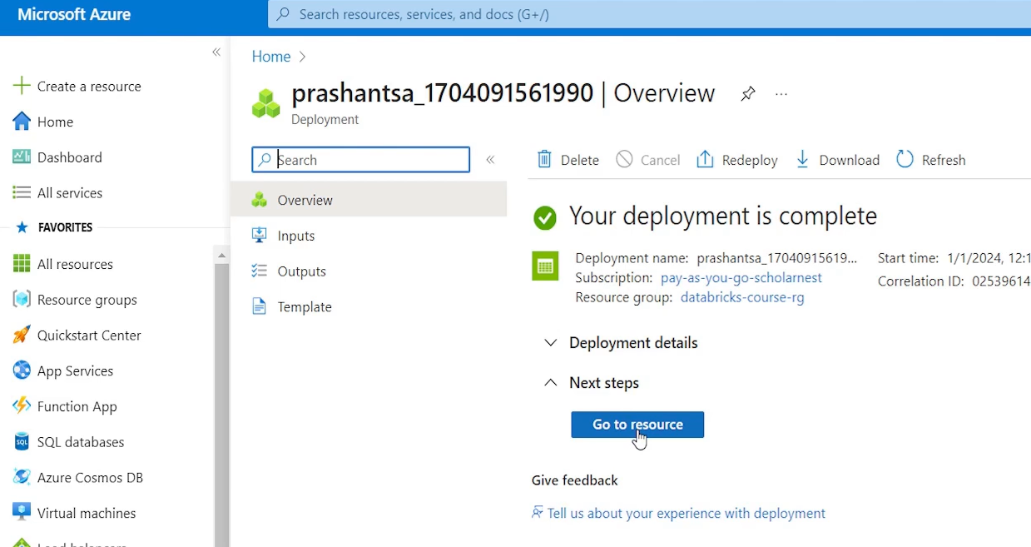

Let's not directly jump from here. Maybe you can come to home and you will also see is your storage account name here. And if you click that you will come to the storage account resource page. So that's your storage account.